Supporting Information for
A Continuous Flow Protocol for the Synthesis of Alkenyl Thioethers Based on the Photochemical Activation of Halogen-Bonding Complexes
Helena F. Piedra, Carlos Valdés and Manuel Plaza*
Departamento de Química Orgánica e Inorgánica and Instituto Universitario de Química Organometálica “Enrique Moles”. Universidad de Oviedo. c/ Julián Clavería 8. Oviedo. 33006. Spain.
Corresponding author: plazamanuel@uniovi.es
CONTENTS
1.- General considerations ...………………………………………………………………….2
2.- Continuous flow protocol …………………………………………………………………..4
3.- General procedures for the synthesis and
characterization data for the compounds 3 …………………………………………………6
4.- Copies of the NMR spectra ………………………………………………………………15
1.- General considerations
All of the vinyl bromides 1 were prepared following previously reported methodologies. The different bases and thiols 2 employed during the development of this work are commercially available from Sigma Aldrich Chemical co., Acros Organics Chemical co. and Alfa Aesar Chemical co. Dry DMSO stored with molecular sieves acquired from Sigma Aldrich Chemical co. was used for the photochemical reactions.
A Kessil® PR160 Rig equipped with different lamps (PR160-366nm, PR160-390nm, PR160-427nm, PR160-440nm and PR160-456nm) and a cooling fan was used as the photochemistry setup. A PR time controller was additionally used to select the irradiation time. 5 mL glass vials purchased in VWR® were used to run the photochemical reactions. The vials were sealed with a cap after adding the chemicals and solvent and placed at a distance of approximately 5 cm away from the lamp prior to irradiation at maximum intensity (100% power) of the Kessil lamp. Figures 1 to 3 illustrate relevant photophysical properties of the lamps.
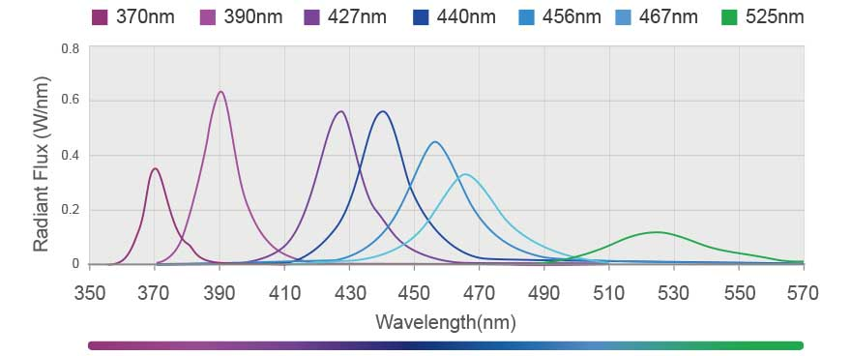
Figure SI-1. Emission spectrums of the different Kessil® lamps.

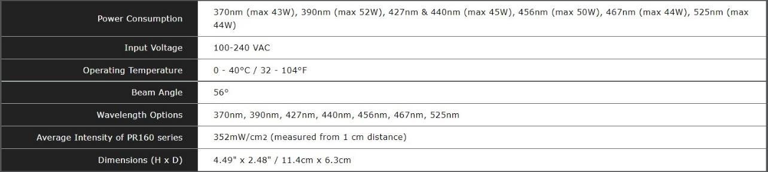
Figure SI-2. Technical specifications of the Kessil® lamps.
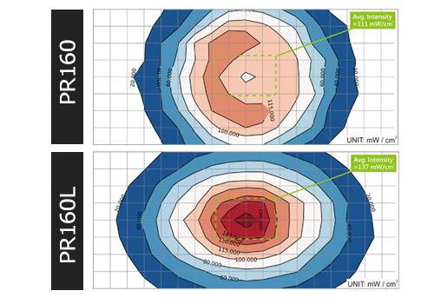
Figure SI-3. Intensity map of the Kessil® lamps.
NMR spectra were recorded in CDCl₃ at 600 MHz and 300 MHz for ¹H, 75 MHz, 100 MHz and 150 MHz for ¹³C and 282 MHz for ¹⁹F, with tetramethylsilane as internal standard for ¹H and the residual solvent signals as standard for ¹³C. The data is being reported as s = singlet, bs = broad singlet, d = doublet, dd = double doublet, t = triplet, dt = double triplet, q = quatriplet, p = quintuplet and m = multiplet or unresolved, chemical shifts in ppm and coupling constant(s) in Hz. The values of the chemical shift of the signals in the NMR reports are in ppms. HRMS were measured in ESI, EI or APCI mode, and the mass analyser of the HRMS was TOF (Bruker model Impact II).
Melting points were measured in a Gallenkamp apparatus.

2. Continuous flow protocol
The Photochemical flow reactor
The flow reactor involved PTFE tubing with a 1 mm internal diameter, coiled around a Eparent, colourless polystyrene sheet measuring 10cm x 10cm. The panel used contained 9 mL in volume and utilized 11.5 meters of PTFE tubing. The end of the photoreactor connected to a 20 psi back pressure regulator (BPR) via a flangeless fitting, with the BPR's exit linked to a collector flask. The initial end of the PTFE tubing in the flow reactor was connected to a syringe holding the solution, operated by a syringe pump to drive the reaction solution through the reactor into the collector flask.
For illumination, a Kessil® PR160L lamp emitting light at a 427 nm wavelength was positioned 3-7 cm away from the photoreactor. This lamp was secured to a PR160 Rig with Fan Kit by Kessil to prevent excessive heating of the reaction caused by radiation (see figures SI-4 and SI-5 for further details).
Figure SI-4. Scheme of the set up for the continuous flow reactions.

- Materials:
PTFE tubing: Ø 0.1 mm X Ø 0.16 mm from BOLA (ref. S 1810-12)
Back pressure regulator: P-763 BPR Cartridge from IDEX health and science
LED lamps: PR160L 427nm.
Fan kit: Kessil PR160 Rig with Fan Kit
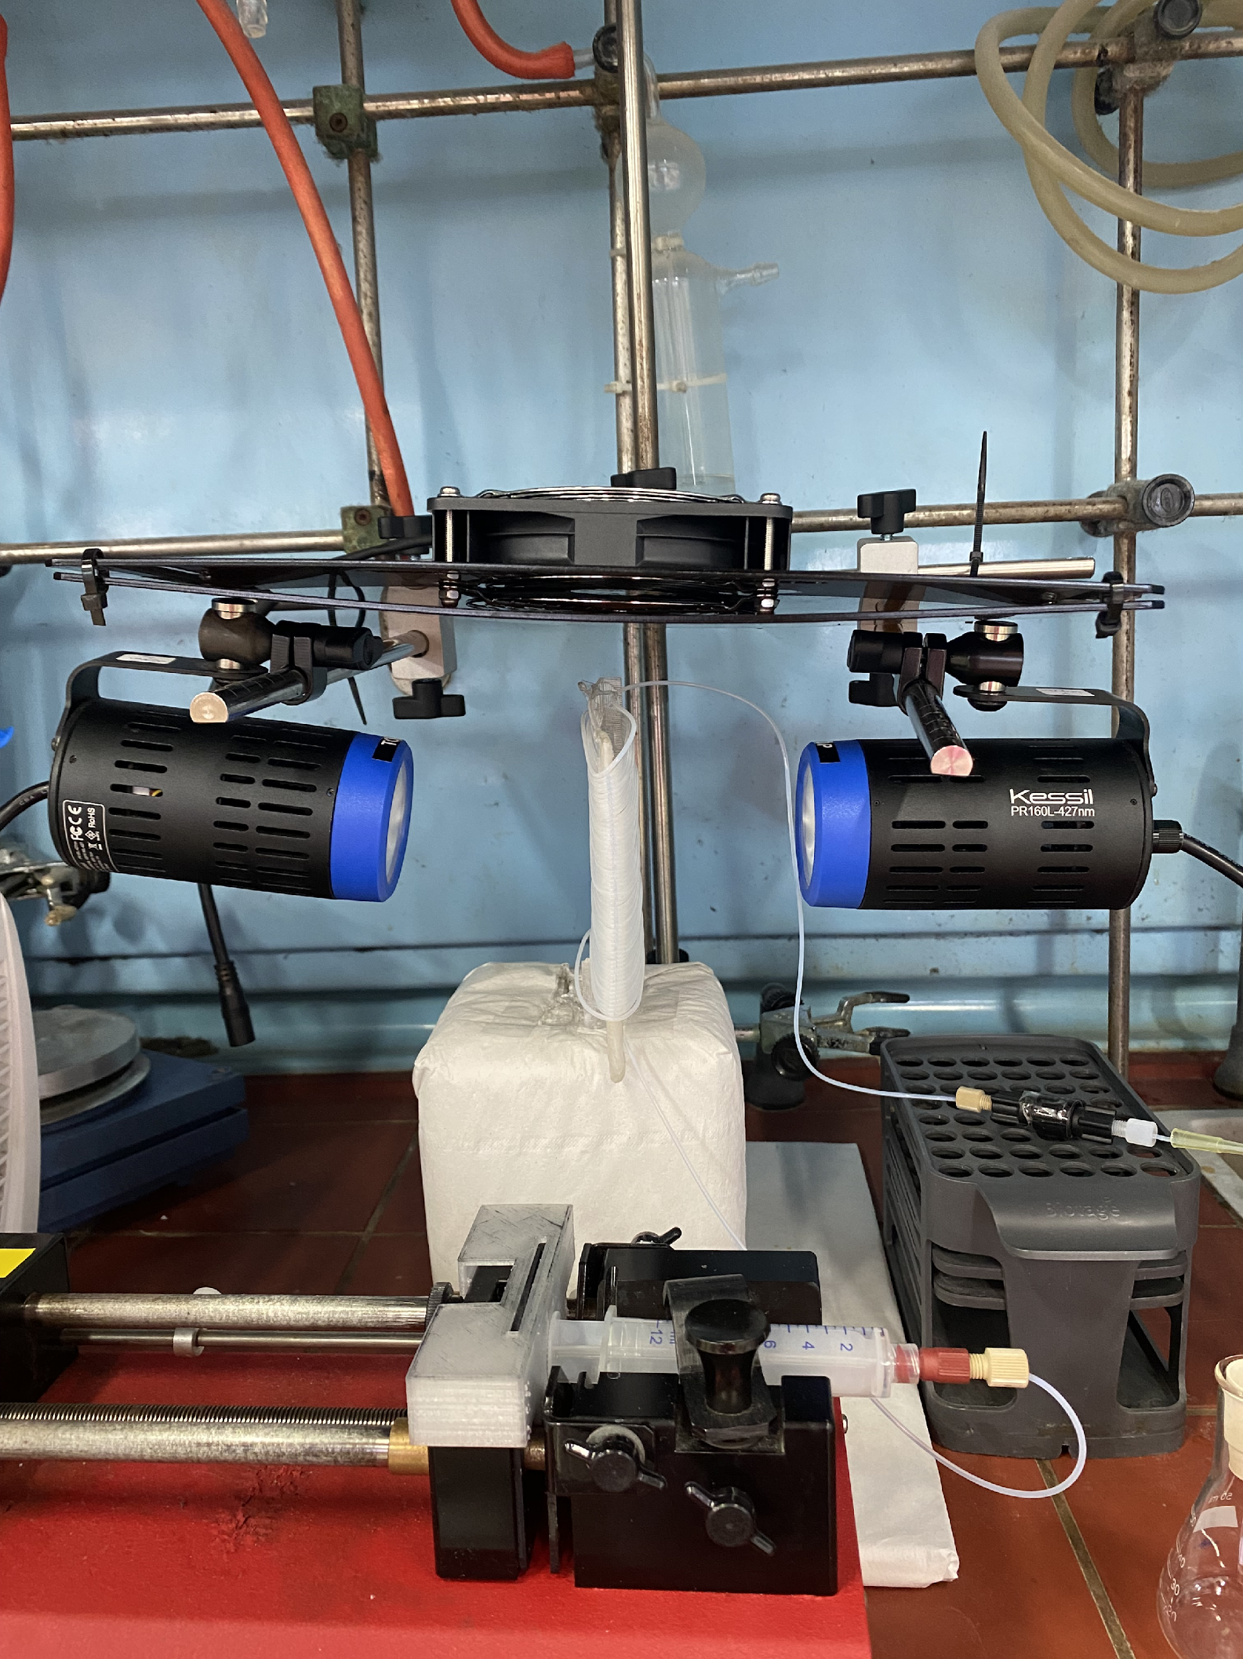
Photoreactor
Refrigerating fan
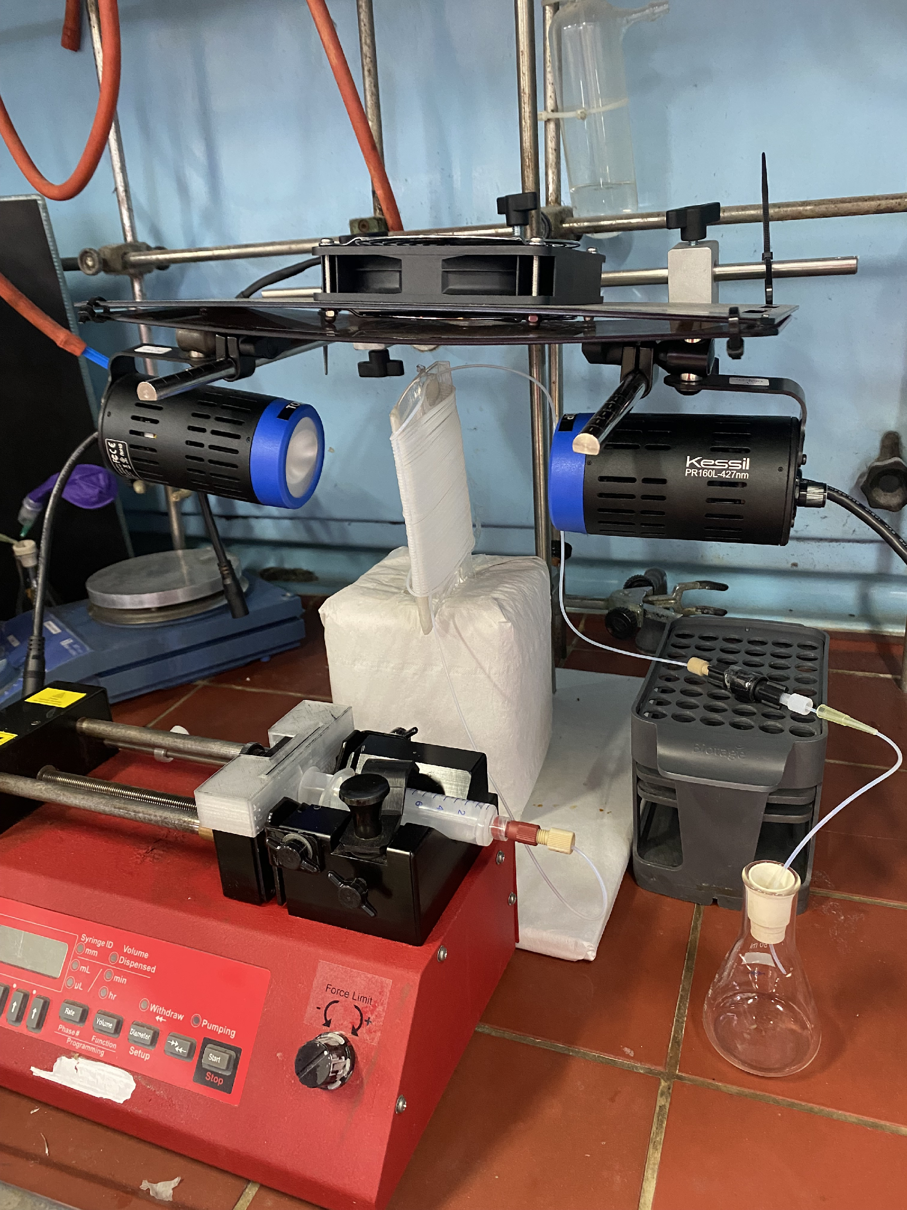
BPR
Collector flask
Syringe pump
Figure SI-5. Pictures of the setup.
3. General procedures for the synthesis and characterization data for the compounds 3.
General procedure A (for the synthesis of compounds 3)
A solution of vinyl bromide 1 (0.52 mmol), thiol 2 (0.80 mmol) and NaOH (0.80 mmol) in dry DMSO (4 mL) was prepared and loaded into a syringe. This syringe was connected to a high-pressure pump and a photoreactor. The solution was continuously pumped through the system at a rate of 4 mL/h while one Kessil lamp (PRL160, emitting at 427 nm) was turned on. DMSO was used to drive the reaction into a collector flask as the solution entered the reactor. The reaction was quenched by adding 10 mL of water and the resulting mixture was diluted with 15 mL of Et₂O and transferred to a separation funnel. The aqueous phase was subjected to three extraction cycles with 15 mL of Et₂O each, while the combined organic phases were washed with 20 mL of brine and then dried with Na₂SO₄. The solvents were evaporated under reduced pressure, and the crude product was purified by flash chromatography using a mixture of Hexane/EtOAc, yielding the corresponding vinyl sulfides 3 in a pure form.

Characterization data for the compounds 3.
(E)-Phenyl(styryl)sulfane (3aa)
Following the general procedure A, the vinyl bromide 1a (67 µL, 0.52 mmol), thiol 2a (82 µL, 0.80 mmol) and freshly ground NaOH (32 mg, 0.80 mmol) were dissolved in 4 mL of dry DMSO. After purification by flash chromatography in SiO₂ (50:1 Hex/EtOAc), 72 mg of 3aa (65% isolated yield, d.r.: 5.5:1 trans/cis) as a colourless oil were obtained.
Large scale synthesis: Following the general procedure A, the vinyl bromide 1a (670 µL, 5.2 mmol), thiol 2a (820 µL, 8 mmol) and freshly ground NaOH (320 mg, 8 mmol) were dissolved in 40 mL of dry DMSO. After purification by flash chromatography in SiO₂ (50:1 Hex/EtOAc), 720 mg of 3aa (65% isolated yield, d.r.: 5.5:1 trans/cis) as a colourless oil were obtained.
A 5.5:1 trans/cis isomeric mixture was obtained. For simplicity, the integrals in the ¹H-NMR spectra have been adjusted to the major (trans) isomer. The signals of the corresponding cis isomer have also been analysed.
¹H NMR (300 MHz, CDCl₃, 300K) δ 7.59 – 7.21 (m, 10H + cis isom.), 6.91 (d, J = 15.4 Hz, 1H), 6.76 (d, J = 15.5 Hz, 1H), 6.62 (d, J = 10.8 Hz, cis isom.), 6.53 (d, J = 10.7 Hz, cis isom.).
¹³C NMR (75 MHz, CDCl₃, 300K) δ 136.6 (C), 135.3 (C), 131.8 (CH), 129.9 (CH), 129.2 (CH), 128.7 (CH), 127.6 (CH), 127.0 (CH), 126.0 (CH), 123.4 (CH).
(E)-(3,5-Dimethylstyryl)(phenyl)sulfane (3ba)
Following the general procedure A, the vinyl bromide 1b (109.8 mg, 0.52 mmol), thiol 2a (82 µL, 0.80 mmol) and freshly ground NaOH (32 mg, 0.80 mmol) were dissolved in 4 mL of dry DMSO. After purification by flash chromatography in SiO₂ (50:1 Hex/EtOAc), 82 mg of 3ba (65% isolated yield, d.r.: 6.3:1 trans/cis) as a colourless oil were obtained.
A 6.3:1 trans/cis isomeric mixture was obtained. For simplicity, the integrals in the 1HNMR spectra have been adjusted to the major (trans) isomer. The signals of the corresponding cis isomer have also been analyzed.
¹H NMR (300 MHz, CDCl₃, 300K) δ 7.55 – 7.23 (m, 7H + cis isom.), 7.01 (s, 1H + cis isom.), 6.90 (d, J = 15.5 Hz, 1H), 6.73 (d, J = 15.4 Hz, 1H), 6.58 (d, J = 10.7 Hz, cis isom.), 6.49 (d, J = 10.7 Hz, cis isom.), 2.34 (s, 6H + cis isom.).
¹³C NMR (75 MHz, CDCl₃, 300K) δ 138.2 (C), 136.5 (C), 135.6 (C), 132.4 (CH), 129.7 (CH), 129.5 (CH), 129.2 (CH), 126.9 (CH), 124.0 (CH), 122.7 (CH), 21.3 (CH₃).
(E)-(2-(naphthalen-2-yl)vinyl)(phenyl)sulfane (3ca)
Following the general procedure A, the vinyl bromide 1c (122 mg, 0.52 mmol), thiol 2a (82 µL, 0.80 mmol) and freshly ground NaOH (32 mg, 0.80 mmol) were dissolved in 4 mL of dry DMSO. After purification by flash chromatography in SiO₂ (25:1 Hex/EtOAc), 71 mg of 3ca (52% isolated yield, d.r.: 1.2:1 trans/cis) as a colourless oil were obtained.
A 1.2:1 trans/cis isomeric mixture was obtained. For simplicity, the integrals in the ¹H-NMR spectra have been adjusted to the major (trans) isomer. The signals of the corresponding cis isomer have also been analysed.
¹H NMR (300 MHz, CDCl₃, 300K) δ 8.07 – 7.76 (m, 2H + cis isom.), 7.74 – 7.65 (m, 1H + cis isom.), 7.61 – 7.24 (m, 8H + cis isom.), 7.05 (d, J = 15.5 Hz, 1H), 6.90 (d, J = 15.5 Hz, 1H), 6.76 (d, J = 10.7 Hz, cis isom.), 6.62 (d, J = 10.7 Hz, cis isom.).
¹³C NMR (75 MHz, CDCl₃, 300K) δ 135.2 (C), 134.1 (C), 133.7 (C), 133.0 (C), 131.6 (CH), 130.2 (CH), 130.1 (CH), 129.3 (CH), 128.4 (CH), 128.0 (CH), 127.8 (CH), 127.3 (CH), 127.1 (CH), 126.5 (CH), 126.0 (CH), 125.8 (CH), 124.0 (CH), 123.3 (CH).

(E)-4-(2-(Phenylthio)vinyl)benzonitrile (3da)
Following the general procedure A, the vinyl bromide 1d (108 mg, 0.52 mmol), thiol 2a (82 µL, 0.80 mmol) and freshly ground NaOH (32 mg, 0.80 mmol) were dissolved in 4 mL of dry DMSO. After purification by flash chromatography in SiO₂ (20:1 Hex/EtOAc), 77 mg of 3ea (62% isolated yield, d.r.: 3.2:1 trans/cis) as a white solid were obtained.
A 3.2:1 trans/cis isomeric mixture was obtained. For simplicity, the integrals in the ¹H-NMR spectra have been adjusted to the major (trans) isomer. The signals of the corresponding cis isomer have also been analyzed.
¹H NMR (300 MHz, CDCl₃, 300K) δ 7.70 – 7.23 (m, 9H + cis isom.), 7.07 (d, J = 15.6 Hz, 1H), 6.72 (d, J = 10.9 Hz, cis isom.), 6.60 – 6.49 (m, 1H + cis isom.).
¹³C NMR (75 MHz, CDCl₃, 300K) δ 140.9 (C), 133.4 (C), 132.5 (CH), 131.2 (CH), 129.9 (CH), 129.5 (CH), 128.0 (CH), 127.1 (CH), 126.2 (CH), 119.0 (C), 110.2 (C).

(E)-(4-Fluorostyryl)(phenyl)sulfane (3ea)
Following the general procedure A, the vinyl bromide 1f (52.3 mg, 0.52 mmol), thiol 2a (82 µL, 0.80 mmol) and freshly ground NaOH (32 mg, 0.80 mmol) were dissolved in 4 mL of dry DMSO. After purification by flash chromatography in SiO₂ (50:1 Hex/EtOAc), 105 mg of 3ea (88% isolated yield, d.r.: 7.4:1 trans/cis) as a yellow oil were obtained.
A 7.4:1 trans/cis isomeric mixture was obtained. For simplicity, the integrals in the ¹H-NMR spectra have been adjusted to the major (trans) isomer. The signals of the corresponding cis isomer have also been analyzed.
¹H NMR (300 MHz, CDCl₃, 300K) δ 7.59 – 7.20 (m, 7H + cis isom.), 7.16 – 6.95 (m, 2H + cis isom.), 6.82 (d, J = 15.5 Hz, 1H), 6.70 (d, J = 15.5 Hz, 1H), 6.57 (d, J = 10.8 Hz, cis isom.), 6.49 (d, J = 10.7 Hz, cis isom.).
¹³C NMR (75 MHz, CDCl₃, 300K) δ 162.3 (d, ¹J_{C-F} = 247.2 Hz, C), 135.1 (C), 132.8 (C), 130.6 (CH), 129.9 (CH), 129.2 (CH), 127.6 (CH), 127.6 (CH), 127.1 (CH), 123.2 (CH), 115.7 (d, ²J_{C-F} = 21.8 Hz, CH).
¹⁹F NMR (282 MHz, CDCl₃, 300K) δ -114.1, -114.1 (cis isom.).

(E)-methyl(4-(2-(phenylthio)vinyl)phenyl)sulfane (3fa)
Following the general procedure A, the vinyl bromide 1j (114 mg, 0.52 mmol), thiol 2a (82 µL, 0.80 mmol) and freshly ground NaOH (32 mg, 0.80 mmol) were dissolved in 4 mL of dry DMSO. After purification by flash chromatography in SiO₂ (50:1 Hex/EtOAc), 74 mg of 3fa (55% isolated yield, d.r.: 4.8:1 trans/cis) as a colorless oil were obtained.
A 4.8:1 trans/cis isomeric mixture was obtained. For simplicity, the integrals in the ¹H-NMR spectra have been adjusted to the major (trans) isomer. The signals of the corresponding cis isomer have also been analysed.
¹H NMR (300 MHz, CDCl₃, 300K) δ 7.52 – 7.16 (m, 9H + cis isom.), 6.85 (d, J = 15.5 Hz, 1H), 6.69 (d, J = 15.4 Hz, 1H), 6.55 (d, J = 10.7 Hz, cis isom.), 6.47 (d, J = 10.7 Hz, cis isom.), 2.49 (s, 3H + cis isom.).
¹³C NMR (75 MHz, CDCl₃, 300K) δ 137.9 (C), 135.3 (C), 133.5 (C), 131.4 (CH), 129.8 (CH), 129.2 (CH), 127.0 (CH), 126.7 (CH), 126.4 (CH), 122.7 (CH), 15.8 (CH₃).

Methyl (E)-3-(2-(phenylthio)vinyl)benzoate (3ga)
Following the general procedure A, the vinyl bromide 1g (96 mg, 0.52 mmol), thiol 2a (82 µL, 0.80 mmol) and freshly ground NaOH (32 mg, 0.80 mmol) were dissolved in 4 mL of dry DMSO. After purification by flash chromatography in SiO₂ (8:1 Hex/EtOAc), 77 mg of 3ga (55% isolated yield, d.r.: 4.9:1 trans/cis) as a colorless oil were obtained.
A 4.9:1 trans/cis isomeric mixture was obtained. For simplicity, the integrals in the ¹H-NMR spectra have been adjusted to the major (trans) isomer. The signals of the corresponding cis isomer have also been analysed.
¹H NMR (300 MHz, CDCl₃, 300K) δ 8.19 (s, cis isom.) 8.01 (s, 1H), 7.98 – 7.85 (m, 1H + cis isom.), 7.54 – 7.23 (m, 7H + cis isom.), 6.99 (d, J = 15.5 Hz, 1H), 6.69 (d, J = 15.5 Hz, 1H), 6.62 (d, J = 10.9 Hz, cis isom.), 6.60 (d, J = 10.9 Hz, cis isom.), 3.92 (s, 3H + cis isom.).
¹³C NMR (75 MHz, CDCl₃, 300K) δ 166.9 (C), 136.9 (C), 134.5 (C), 130.6 (C), 130.4 (CH), 130.3 (CH), 129.6 (CH), 129.3 (CH), 128.8 (CH), 128.4 (CH), 127.4 (CH), 126.9 (CH), 125.6 (CH), 52.1 (CH₃).

(E)-(2-methylstyryl)(phenyl)sulfane (3ha)
Following the general procedure A, the vinyl bromide 1h (126 mg, 0.52 mmol), thiol 2a (82 µL, 0.80 mmol) and freshly ground NaOH (32 mg, 0.80 mmol) were dissolved in 4 mL of dry DMSO. After purification by flash chromatography in SiO₂ (8:1 Hex/EtOAc), 80 mg of 3ha (68% isolated yield, d.r.: 2.4:1 trans/cis) as a colorless oil were obtained.
A 2.4:1 trans/cis isomeric mixture was obtained. For simplicity, the integrals in the ¹H-NMR spectra have been adjusted to the major (trans) isomer. The signals of the corresponding cis isomer have also been analysed.
¹H NMR (300 MHz, CDCl₃, 300K) δ 7.50 – 7.11 (m, 9H + cis isom.), 7.00 (d, J = 15.3 Hz, 1H), 6.81 (d, J = 15.3 Hz, 1H), 6.75 (d, J = 10.5 Hz, cis isom.), 6.58 (d, J = 10.5 Hz, cis isom.), 2.36 (s, 3H + cis isom.).
¹³C NMR (75 MHz, CDCl₃, 300K) δ 135.6 (C), 135.5 (C), 135.2 (C), 130.5 (CH), 130.1 (CH), 129.6 (CH), 129.2 (CH), 127.7 (CH), 126.9 (CH), 126.2 (CH), 125.3 (CH), 124.2 (CH), 19.9 (CH₃).

(E)-Methyl(4-(styrylthio)phenyl)sulfane (3ab)
Following the general procedure A, the vinyl bromide 1a (67 µL, 0.52 mmol), thiol 2b (125 mg, 0.80 mmol) and freshly ground NaOH (32 mg, 0.80 mmol) were dissolved in 4 mL of dry DMSO. After purification by flash chromatography in SiO₂ (20:1 Hex/EtOAc), 93 mg of 3ab (69% isolated yield, d.r.: 2.3:1 trans/cis) as a white solid were obtained.
A 2.3:1 trans/cis isomeric mixture was obtained. For simplicity, the integrals in the ¹H-NMR spectra have been adjusted to the major (trans) isomer. The signals of the corresponding cis isomer have also been analyzed.
¹H NMR (300 MHz, CDCl₃, 300K) δ 7.57 – 7.15 (m, 9H + cis isom.), 6.85 (d, J = 15.4 Hz, 1H), 6.68 (d, J = 15.5 Hz, 1H), 6.59 (d, J = 10.7 Hz, cis isom.), 6.45 (d, J = 10.7 Hz, cis isom.), 2.50 (s, 3H + cis isom.).
¹³C NMR (75 MHz, CDCl₃, 300K) δ 138.2 (C), 136.5 (C), 135.6 (C), 132.4 (CH), 192.7 (CH), 129.5 (CH), 129.2 (CH), 126.9 (CH), 124.0 (CH), 122.7 (CH), 21.3 (CH₃).
(E)-Cyclohexyl(styryl)sulfane (3ac)
Following the general procedure A, the vinyl bromide 1a (67 µL, 0.52 mmol), thiol 2c (98 µL, 0.80 mmol) and freshly ground NaOH (32 mg, 0.80 mmol) were dissolved in 4 mL of dry DMSO. After purification by flash chromatography in SiO₂ (hexane), 73 mg of 3ac (64% isolated yield, d.r.: 4.8:1 trans/cis) as an orange oil were obtained.
A 4.8:1 trans/cis isomeric mixture was obtained. For simplicity, the integrals in the ¹H-NMR spectra have been adjusted to the major (trans) isomer. The signals of the corresponding cis isomer have also been analyzed.
¹H NMR (300 MHz, CDCl₃, 300K) δ 7.53 – 7.14 (m, 5H + cis isom.), 6.79 (d, J = 15.6 Hz, 1H), 6.59 (d, J = 15.6 Hz, 1H), 6.45 (d, J = 11.0 Hz, cis isom.), 6.35 (d, J = 11.0 Hz, cis isom.), 3.08 – 2.83 (m, 1H + cis isom.), 2.15 – 1.98 (m, 2H + cis isom.), 1.92 – 1.72 (m, 2H + cis isom.), 1.69 – 1.16 (m, 5H + cis isom.).
¹³C NMR (75 MHz, CDCl₃, 300K) δ 137.2 (C), 128.6 (CH), 126.9 (CH), 125.6 (CH), 124.1 (CH), 45.3 (CH), 33.6 (CH₂), 26.1 (CH₂), 25.7 (CH₂).

Methyl (E)-2-(styrylthio)acetate (3ad)
Following the general procedure A, the vinyl bromide 1a (67 µL, 0.52 mmol), thiol 2d (72 µL, 0.80 mmol) and freshly ground K₂CO₃ (110 mg, 0.80 mmol) were dissolved in 4 mL of dry DMSO. After purification by flash chromatography in SiO₂ (5:1 Hex/EtOAc), 53 mg of 3ad (48% isolated yield, d.r.: 7.4:1 trans/cis) as a colourless oil were obtained.
A 7.4:1 trans/cis isomeric mixture was obtained. For simplicity, the integrals in the ¹H-NMR spectra have been adjusted to the major (trans) isomer. The signals of the corresponding cis isomer have also been analysed.
¹H NMR (300 MHz, CDCl₃, 300K) δ 7.49 – 7.16 (m, 5H + cis isom.), 6.76 (d, J = 15.5 Hz, 1H), 6.60 (d, J = 15.6 Hz, 1H), 6.52 (d, J = 10.8 Hz, cis isom.), 6.33 (d, J = 10.9 Hz, cis isom.), 3.77 (s, 3H + cis isom.), 3.52 (s, 2H), 3.48 (s, cis isom.).
¹³C NMR (75 MHz, CDCl3) δ 170.0 (C), 136.5 (C), 129.4 (CH), 128.7 (CH), 128.7 (CH), 128.3 (CH), 127.4 (CH), 127.1 (CH), 125.9 (CH), 125.0 (CH), 122.8 (CH), 52.7 (CH₃), 36.4 (CH₂), 34.7 (CH₃).

Methyl (E)-2-(styrylthio)benzoate (3ae)
Following the general procedure A, the vinyl bromide 1a (67 µL, 0.52 mmol), thiol 2e (110 µL, 0.80 mmol) and freshly ground NaOH (32 mg, 0.80 mmol) were dissolved in 4 mL of dry DMSO. After purification by flash chromatography in SiO₂ (10:1 Hex/EtOAc), 73 mg of 3ae (52% isolated yield, d.r.: 2.1:1 trans/cis) as a colorless oil were obtained.
A 2.1:1 trans/cis isomeric mixture was obtained. For simplicity, the integrals in the ¹H-NMR spectra have been adjusted to the major (trans) isomer. The signals of the corresponding cis isomer have also been analysed.
¹H NMR (300 MHz, CDCl₃, 300K) δ 8.06 – 7.91 (m, 1H + cis isom.), 7.69 – 7.15 (m, 8 H + cis isom.), 7.05 (d, J = 15.4 Hz, 1H), 6.91 (d, J = 15.4 Hz, 1H), 6.83 (d, J = 10.8 Hz, cis isom.), 6.51 (d, J = 10.7 Hz, cis isom.), 3.95 (s, 3H + cis isom.).
¹³C NMR (75 MHz, CDCl3) δ 166.7 (C), 141.3 (C), 140.1 (C), 136.9 (CH), 136.1 (C), 132.5 (CH), 131.3 (CH), 128.8 (CH), 128.3 (CH), 128.2 (CH), 126.5 (CH), 125.0 (CH), 121.4 (CH), 52.3 (CH₃).

(E)-octyl(styryl)sulfane (3af)
Following the general procedure A, the vinyl bromide 1a (67 µL, 0.52 mmol), thiol 2f (139 µL, 0.80 mmol) and freshly ground NaOH (32 mg, 0.80 mmol) were dissolved in 4 mL of dry DMSO. After purification by flash chromatography in SiO₂ (50:1 Hex/EtOAc), 98 mg of 3af (76% isolated yield, d.r.: 7.5:1 trans/cis) as a colorless oil were obtained.
A 7.5:1 trans/cis isomeric mixture was obtained. For simplicity, the integrals in the ¹H-NMR spectra have been adjusted to the major (trans) isomer. The signals of the corresponding cis isomer have also been analysed.
¹H NMR (300 MHz, CDCl₃, 300K) δ 7.60 – 7.12 (m, 5H), 6.76 (d, J = 15.6 Hz, 1H), 6.48 (d, J = 15.5 Hz, 1H + cis isom.), 6.27 (d, J = 11.0 Hz, cis isom.), 2.82 (t, J = 7.3 Hz, 2H + cis isom.), 1.80 – 1.62 (m, 2H), 1.54 – 1.39 (m, 2H + cis isom.), 1.38 – 1.23 (m, 8H + cis isom.), 0.97 – 0.86 (m, 3H + cis isom.).
¹³C NMR (75 MHz, CDCl3) δ 137.2 (C), 128.6 (CH), 126.8 (CH), 126.6 (CH), 125.5 (CH), 125.4 (CH), 32.6 (CH₂), 31.9 (CH₂), 29.5 (CH₂), 29.2 (CH₂), 28.9 (CH₂), 22.7 (CH₂), 14.2 (CH₃).
Data in accordance with the literature.

(E)-2-(2-(phenylthio)vinyl)benzofuran (3ia)
Following the general procedure A, the vinyl bromide 1i (116 mg, 0.52 mmol), thiol 2a (82 µL, 0.80 mmol) and freshly ground NaOH (32 mg, 0.80 mmol) were dissolved in 4 mL of dry DMSO. After purification by flash chromatography in SiO₂ (50:1 Hex/EtOAc), 91 mg of 3ia (69% isolated yield, d.r.: 4.9:1 trans/cis) as a yellow oil were obtained.
A 4.9:1:1 trans/cis isomeric mixture was obtained. For simplicity, the integrals in the ¹H-NMR spectra have been adjusted to the major (trans) isomer. The signals of the corresponding cis isomer have also been analysed.
¹H NMR (600 MHz, CDCl₃, 300K) δ 7.63 – 7.52 (m, 3H + cis isom.), 7.48 – 7.20 (m, 7H + cis isom.), 6.70 (d, J = 10.9 Hz, cis isom.), 6.60 (d, J = 10.9 Hz, cis isom.), 6.54 (d, J = 15.3 Hz, 1H), 6.51 (s, 1H).
¹³C NMR (75 MHz, CDCl3) δ 154.8 (C), 153.9 (C), 133.8 (C), 130.9 (CH), 129.4 (CH), 129.0 (C), 127.7 (CH), 127.1 (CH), 124.4 (CH), 122.9 (CH), 120.9 (CH), 117.7 (CH), 110.8 (CH), 103.5 (CH).

4. Copies of the NMR spectra
(E)-Phenyl(styryl)sulfane (3aa)

(E)-(3,5-Dimethylstyryl)(phenyl)sulfane (3ba)

(E)-(2-(naphthalen-2-yl)vinyl)(phenyl)sulfane (3ca)

(E)-4-(2-(Phenylthio)vinyl)benzonitrile (3da)

(E)-(4-Fluorostyryl)(phenyl)sulfane (3ea)

(E)-methyl(4-(2-(phenylthio)vinyl)phenyl)sulfane (3fa)

Methyl (E)-3-(2-(phenylthio)vinyl)benzoate (3ga)

(E)-(2-methylstyryl)(phenyl)sulfane (3ha)

(E)-Methyl(4-(styrylthio)phenyl)sulfane (3ab)

(E)-Cyclohexyl(styryl)sulfane (3ac)

Methyl (E)-2-(styrylthio)acetate (3ad)

Methyl (E)-2-(styrylthio)benzoate (3ae)
(E)-octyl(styryl)sulfane (3ae)

(E)-2-(2-(phenylthio)vinyl)benzofuran (3ia)

b) For the synthesis of the vinyl bromides 1, we followed a two-step sequence based on a dibromoolefination reaction of the corresponding aldehyde precursor (A. R. Silva, E. C. Polo, N. C. Martins, Correia, D. C. Roque. Adv. Synth. Catal. 2018, 360, 346.) followed by a dehalogenation reaction (Y. Ye, H. Chen, K. Yao, H. Gong. Org. Lett. 2020, 22, 2070.). b) The cis-configured vinyl bromide 1a’ was synthesized following this procedure: K. G. Tang, G. T. Kent, I. Erden, W. Wu. Tetrahedron Lett. 2017, 58, 3894.
S. Maji, A. Das, M. M. Bhatt, S. K. Mandal. Nat. Catal, 2024, 7, 375.

