Supporting Information for
Synthesis of Vinyl and 1,3-Dienyl Sulfones Enabled by Photochemical Excitation of Halogen-Bonding Complexes
Helena F. Piedra,† Carlos Valdés,† and Manuel Plaza*,†
† Departamento de Química Orgánica e Inorgánica, Instituto Universitario de Química Organometálica “Enrique Moles” and Centro de Innovación en Química Avanzada (ORFEO-CINQA). Universidad de Oviedo. Julián Clavería 8. 33006 Oviedo, Spain.
Corresponding author: plazamanuel@uniovi.es
CONTENTS
1. General considerations……………………………………………………………….……..2
2. Continuous flow protocol.…………………………………………………....……………...4
3. General procedure for the synthesis and characterization data for the compounds 3 and 5…………………………………….…………………………………………….…………6
4. UV-Vis spectra………………...……………….……………………………………...……31
5. Computational studies……………………………………………………………………..32
6. NMR titration experiments…………………………………………………………...……39
7. Quantum yield determination………………………………………………………...……44
8.References…………………………………………….……………………..……………..48
9. Copies of the NMR spectra…………………………………….………………………….50

1. General considerations
All of the vinyl bromides 1 and sulfinate salts 2 were prepared following previously reported methodologies.^{[1,2]} The different reagents employed during the development of this work are commercially available from Sigma Aldrich Chemical co., Acros Organics Chemical co. and Alfa Aesar Chemical co. Dry DMSO stored with molecular sieves acquired from Sigma Aldrich Chemical co. was used for the photochemical reactions.
A Kessil® PR160 Rig equipped with different lamps (PR160-366nm, PR160-390nm, PR160-427nm, PR160-440nm and PR160-456nm) and a cooling fan was used as the photochemistry setup. A PR time controller was additionally used to select the irradiation time. 5 mL glass vials purchased in VWR® were used to run the photochemical reactions. The vials were sealed with a cap after adding the chemicals and solvent and placed at a distance of approximately 5 cm away from the lamp prior to irradiation at maximum intensity (100% power) of the Kessil lamp. Figures SI-1 to SI-3 illustrate relevant photophysical properties of the lamps.
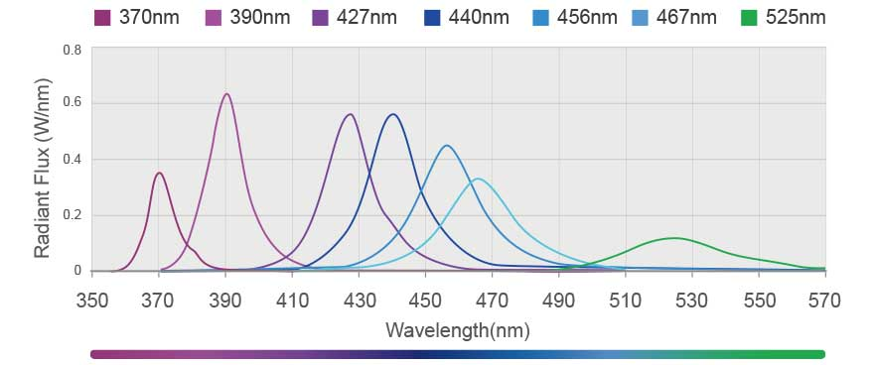
Figure SI-1. Emission spectra of the different Kessil® lamps.

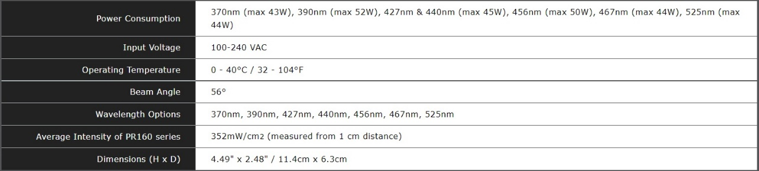
Figure SI-2. Technical specifications of the Kessil® lamps.
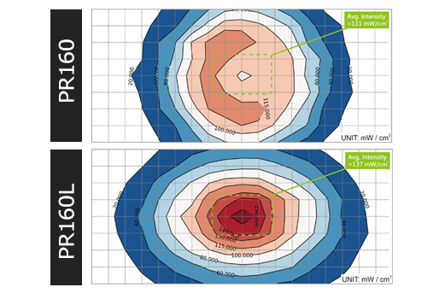
Figure SI-3. Intensity map of the Kessil® lamps.

NMR spectra were recorded in CDCl₃ at 600 MHz and 300 MHz for ¹H, 75 MHz, 100 MHz and 150 MHz for ¹³C and 282 MHz for ¹⁹F, with tetramethylsilane as internal standard for ¹H and the residual solvent signals as standard for ¹³C. The data is being reported as s = singlet, bs = broad singlet, d = doublet, dd = double doublet, t = triplet, dt = double triplet, q = quatriplet, p = quintuplet and m = multiplet or unresolved, chemical shifts in ppm and coupling constant(s) in Hz. The values of the chemical shift of the signals in the NMR reports are in ppms. HRMS were measured in ESI, EI or APCI mode, and the mass analyser of the HRMS was TOF (Bruker model Impact II).
Melting points were measured in a Gallenkamp apparatus.

2. Continuous flow protocol
2.1 Optimization of the flow reactor for the synthesis of compound 3ba (general conditions B).

Entry | Tubing type | Solvent | Length | LED | Time | Yield
1 | PTFE | DMSO | 11.5 m | 427 | 4 mL/h | 75%
2 | PTFE | DMSO | 11.5 m | 427 | 9 mL/h | 24%
3 | PTFE | DMSO | 11.5 m | 427 x2 | 4 mL/h | 80%
4 | PTFE | DMSO | 23.0 m | 427 x 2 | 4 mL/h | 72%
5 | FEP | DMSO | 11.5 m | 427 x 2 | 4 mL/h | 75%
6 | FEP | DMSO | 11.5 m | 427 x 2 | 7 mL/h | 40%

Table SI-1. Optimization of the flow protocol for the synthesis of compound 3ba.

2.2 The Photochemical flow reactor
The optimized flow protocol consisted of a flow reactor made with PTFE tubing with a 1 mm internal diameter, coiled around a Eparent, colourless polystyrene sheet measuring 10cm x 10cm. The panel used contained 9 mL in volume and utilized 11.5 meters of PTFE tubing. The end of the photoreactor connected to a 20 psi back pressure regulator (BPR) via a flangeless fitting, with the BPR's exit linked to a collector flask. The initial end of the PTFE tubing in the flow reactor was connected to a syringe holding the solution, operated by a syringe pump to drive the reaction solution through the reactor into the collector flask.
For illumination, two Kessil® PR160L lamps emitting light at a 427 nm wavelength were positioned 3-7 cm away from the photoreactor. These lamps were secured to a PR160 Rig with Fan Kit by Kessil to prevent excessive heating of the reaction caused by radiation (see figures SI-4 and SI-5 for further details).
Figure SI-4. Scheme of the set up for the continuous flow reactions.

- Materials:
PTFE tubing: Ø 0.1 mm X Ø 0.16 mm from BOLA (ref. S 1810-12)
Back pressure regulator: P-763 BPR Cartridge from IDEX health and science
LED lamps: PR160L 427nm.
Fan kit: Kessil PR160 Rig with Fan Kit
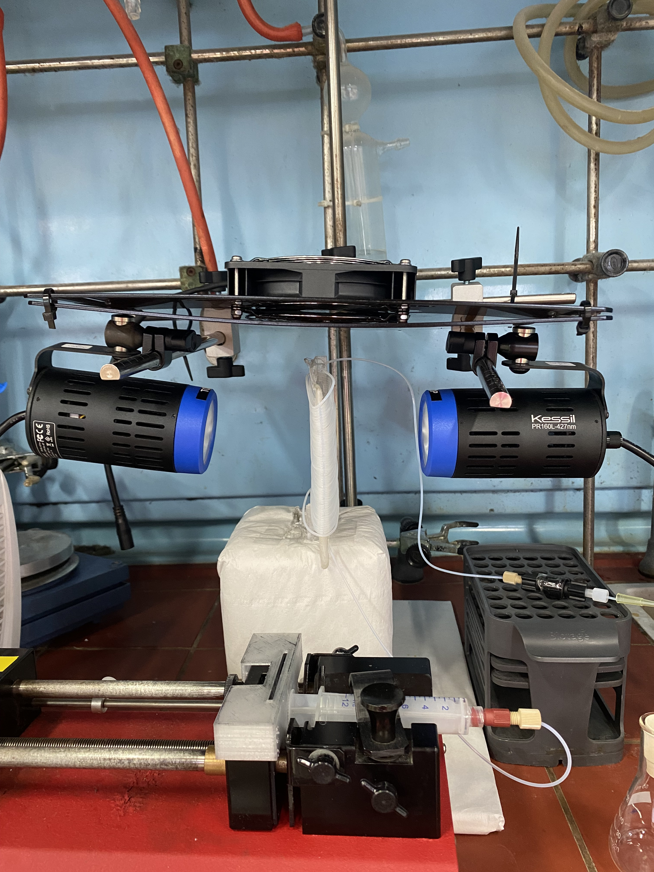
Refrigerating fan
Photoreactor
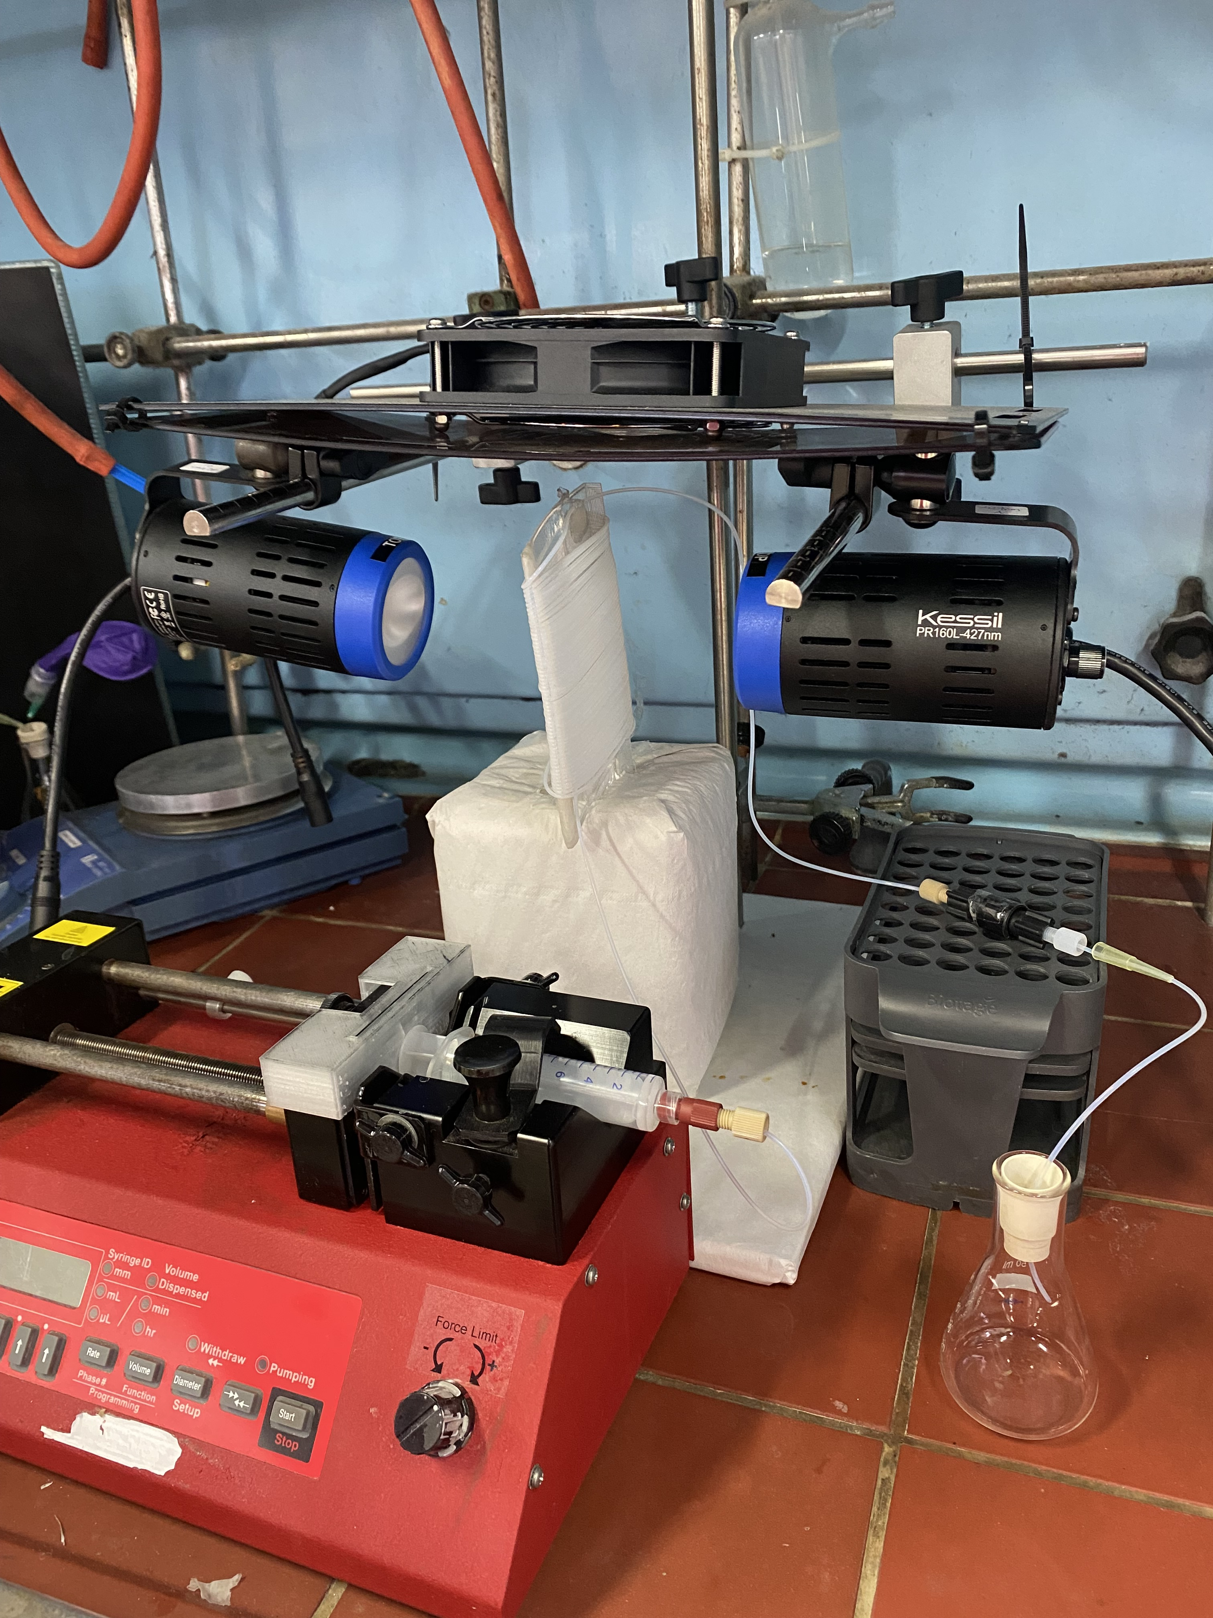
Collector flask
Syringe pump
BPR
Figure SI-5. Pictures of the setup used.

3. General procedures for the synthesis and characterization data for the compounds 3 and 5.
General procedure A (under batch conditions)
Vinyl bromide 1 (0.2 mmol), sulfinate salt 2 (0.3 mmol), and dry DMSO (2 mL) were combined in a 5 mL glass vial. The vial was secured and placed approximately 5 cm in front of the 427 nm Kessil® lamp. Once the lamp and cooling fan were switch on, the reaction mixture was stirred at room temperature for 30 minutes to ensure complete conversion. To stop the reaction, 2 mL of water was introduced. This mixture was then diluted with 5 mL of EtOAc and Eferred to a separating funnel. The aqueous phase was extracted three times with 5 mL of EtOAc, while the combined organic phases were washed with 10 mL of brine and dried using Na₂SO₄. The reaction crude was concentrated in vacuo and analysed by ¹H-NMR or GC/MS to determine the trans/cis ratio. Finally, it underwent flash chromatography (using Hex/EtOAc) to obtain the corresponding sulfone 3.
General procedure B (under continuous flow conditions)
A mixture comprising vinyl bromide 1 (0.4 mmol) and sulfinate salt 2 (0.6 mmol) in dry DMSO (4 mL) was loaded into a syringe and connected to a high-pressure syringe pump and to a photoreactor. The solution was pumped through the system at a rate of 4 mL/h while both Kessil lamps (two PRL160 427 nm) were activated. As the solution entered the reactor, DMSO was employed to propel the reaction into the collector flask. Subsequently, upon completion of the reaction, 15 mL of water was added to quench it. This mixture was further diluted with 15 mL of EtOAc and transferred into a separation funnel. The aqueous phase underwent three extraction cycles, each involving 15 mL of EtOAc, while the combined organic phases were washed with 20 mL brine and were subsequently dried using Na₂SO₄. The solvents were then removed under reduced pressure, and the crude reaction product underwent purification via flash chromatography using a Hexane/EtOAc mixture, ultimately yielding sulfone 3.

Characterization data for the compounds 3 and 5
(E)-(2-(phenylsulfonyl)vinyl)benzene ^{[3]} (3aa)
Batch reaction: Using the standard protocol A, vinyl bromide 1a (26 µL, 0.2 mmol) and sulfinate salt 2a (49.2 mg, 0.3 mmol) were dissolved in 2 mL of anhydrous DMSO. After undergoing purification via column chromatography (3:1 Hex/EtOAc), the resulting product was acquired in the form of a white solid (48 mg, isolated yield of 98%).
Continuous flow reaction: Using procedure B, a mixture of vinyl bromide 1a (0.195 mL, 1.5 mmol) and the sulfinate salt 2a (369 mg, 2.25 mmol) were dissolved in 30 mL of dry DMSO. After purification by column chromatography (3:1 Hex/EtOAc), the product was obtained as a white solid (348 mg, 95% isolated yield).
Rf = 0.26 (3:1 Hex/EtOAc) [UV]
¹H NMR (300 MHz, CDCl₃, 300K) δ 8.03 – 7.92 (m, 2H), 7.71 (d, J = 15.4 Hz, 1H), 7.67 – 7.35 (m, 8H), 6.90 (d, J = 15.4 Hz, 1H).
¹³C NMR (75 MHz, CDCl₃, 300K) δ 142.5 (CH), 140.7 (C), 133.4 (CH), 132.3 (C), 131.3 (CH), 129.4 (CH), 129.1 (CH), 128.6 (CH), 127.7 (CH), 127.3 (CH).

(E)-2-(2-(phenylsulfonyl)vinyl)naphthalene ^{[3]} (3ba)
Batch reaction: Using the standard protocol A, vinyl bromide 1b (46.6 mg, 0.2 mmol) and sulfinate salt 2a (49.2 mg, 0.3 mmol) were dissolved in 2 mL of anhydrous DMSO. After undergoing purification via column chromatography (3:1 Hex/EtOAc), the resulting product was acquired in the form of a white solid (50 mg, isolated yield of 85%).
Continuous flow reaction: Using procedure B, a mixture of vinyl bromide 1b (93.2 mg, 0.4 mmol) and the sulfinate salt 2a (98.5 mg, 0.6 mmol) were dissolved in 4 mL of dry DMSO. After purification by column chromatography (3:1 Hex/EtOAc), the product was obtained as a white solid (94 mg, 80% isolated yield).
Rf = 0.29 (3:1 Hex/EtOAc) [UV]
¹H NMR (300 MHz, CDCl₃, 300K) δ 8.08 – 7.96 (m, 2H), 7.94 (s, 1H), 7.91 – 7.80 (m, 3H), 7.70 – 7.48 (m, 6H), 7.00 (d, J = 15.4 Hz, 1H).
¹³C NMR (75 MHz, CDCl₃, 300K) δ 142.6 (CH), 140.8 (C), 134.5 (C), 133.4 (CH), 133.1 (C), 131.0 (CH), 129.8 (C), 129.4 (CH), 129.0 (CH), 128.7 (CH), 127.9 (CH), 127.7 (CH), 127.3 (CH), 127.0 (CH), 123.4 (CH).

(E)- 1,3-dimethyl-5-(2-(phenylsulfonyl)vinyl)benzene (3ca)
Using the standard protocol A, vinyl bromide 1c (42.2 mg, 0.2 mmol) and sulfinate salt 2a (49.2 mg, 0.3 mmol) were dissolved in 2 mL of anhydrous DMSO. After undergoing purification via column chromatography (3:1 Hex/EtOAc), the resulting product was acquired in the form of a colourless oil (45 mg, isolated yield of 83%, d.r.: 17.1:1 trans/cis).
Rf = 0.48 (3:1 Hex/EtOAc) [UV]
A 17.1:1 trans/cis isomeric mixture was obtained. For simplicity, the integrals in the spectra have been adjusted to the major (E) isomer. The signals of the corresponding Z isomer have also been analysed.
¹H NMR (300 MHz, CDCl₃, 300K) δ 8.01 – 7.92 (m, 2H), 7.71 – 7.50 (m, 3H, + Z isom.), 7.12 (s, 2H), 7.07 (s, 1H), 6.86 (d, J = 15.4 Hz, 1H), 6.53 (d, J = 12.0 Hz, Z isom.), 2.33 (s, 6H, + Z isom.).
¹³C NMR (75 MHz, CDCl₃, 300K) δ 142.9 (CH), 140.9 (C), 138.7 (C), 133.3 (CH), 133.0 (CH), 132.3 (C), 129.3 (CH), 127.6 (CH), 126.8 (CH), 126.5 (CH), 21.2 (CH₃).

(E)-4-(2-(phenylsulfonyl)vinyl)benzonitrile ^{[3]} (3da)
Using the standard protocol A, vinyl bromide 1d (41.6 mg, 0.2 mmol) and sulfinate salt 2a (49.2 mg, 0.3 mmol) were dissolved in 2 mL of anhydrous DMSO. After undergoing purification via column chromatography (3:1 Hex/EtOAc), the resulting product was acquired in the form of a white solid (49 mg, isolated yield of 91%).
Rf = 0.24 (3:1 Hex/EtOAc) [UV]
¹H NMR (300 MHz, CDCl₃, 300K) δ 8.02 – 7.91 (m, 2H), 7.74 – 7.52 (m, 8H), 7.01 (d, J = 15.5 Hz, 1H).
¹³C NMR (75 MHz, CDCl₃, 300K) δ 139.8 (CH), 136.6 (C), 133.9 (CH), 132.8 (CH), 131.0 (CH), 129.6 (CH), 129.0 (CH), 127.9 (CH), 118.1 (C), 114.3 (C).

(E)-1-nitro-4-(2-(phenylsulfonyl)vinyl)benzene ^{[4]} (3ea)
Using the standard protocol A, vinyl bromide 1e (45.6 mg, 0.2 mmol) and sulfinate salt 2a (49.2 mg, 0.3 mmol) were dissolved in 2 mL of anhydrous DMSO. After undergoing purification via column chromatography (3:1 Hex/EtOAc), the resulting product was acquired in the form of a yellow solid (52 mg, isolated yield of 90%).
Rf = 0.24 (3:1 Hex/EtOAc) [UV]
¹H NMR (300 MHz, CDCl₃, 300K) δ 8.31 – 8.19 (m, 2H), 8.03 – 7.93 (m, 2H), 7.74 (d, J = 15.5 Hz, 1H), 7.70 – 7.55 (m, 5H), 7.05 (d, J = 15.5 Hz, 1H).
¹³C NMR (75 MHz, CDCl₃, 300K) δ 149.0 (C), 139.7 (C), 139.3 (CH), 138.4 (C), 134.0 (CH), 131.7 (CH), 129.6 (CH), 129.3 (CH), 127.9 (CH), 124.3 (CH).

(E)-1-fluoro-4-(2-(phenylsulfonyl)vinyl)benzene ^{[3]} (3fa)
Using the standard protocol A, vinyl bromide 1f (40.2 mg, 0.2 mmol) and sulfinate salt 2a (49.2 mg, 0.3 mmol) were dissolved in 2 mL of anhydrous DMSO. After undergoing purification via column chromatography (3:1 Hex/EtOAc), the resulting product was acquired in the form of a white solid (51 mg, isolated yield of 97%, d.r.: 17.6:1 trans/cis).
Rf = 0.35 (3:1 Hex/EtOAc) [UV]
A 17.6:1 trans/cis isomeric mixture was obtained. For simplicity, the integrals in the spectra have been adjusted to the major (E) isomer. The signals of the corresponding Z isomer have also been analysed.
¹H NMR (300 MHz, CDCl₃, 300K) δ 8.02 – 7.92 (m, 2H, + Z isom.), 7.72 – 7.42 (m, 6H, + Z isom.), 7.16 – 7.02 (m, 2H, + Z isom.), 6.83 (d, J = 15.4 Hz, 1H), 6.52 (d, J = 12.0 Hz, Z isom.).
¹³C NMR (75 MHz, CDCl₃, 300K) δ 164.4 (d, J = 253.1 Hz, C), 141.2 (CH), 140.6 (C), 133.5 (CH), 130.7 (d, J = 8.7 Hz, CH), 129.4 (CH), 128.6 (d, J = 3.4 Hz, C), 127.7 (CH), 127.0 (d, J = 2.5 Hz, CH), 116.3 (d, J = 22.2 Hz, CH).
¹⁹F NMR (282 MHz, CDCl₃, 300K) δ -107.7, -109.9.

(E)-1-methoxy-4-(2-(phenylsulfonyl)vinyl)benzene ^{[3]} (3ga)
Using the standard protocol A, vinyl bromide 1g (42.6 mg, 0.2 mmol) and sulfinate salt 2a (49.2 mg, 0.3 mmol) were dissolved in 2 mL of anhydrous DMSO. After undergoing purification via column chromatography (3:1 Hex/EtOAc), the resulting product was acquired in the form of a white solid (53 mg, isolated yield of 96%).
Rf = 0.25 (3:1 Hex/EtOAc) [UV]
¹H NMR (300 MHz, CDCl₃, 300K) δ 8.01 – 7.90 (m, 2H), 7.71 – 7.51 (m, 4H), 7.45 (d, J = 8.8 Hz, 2H), 6.91 (d, J = 8.8 Hz, 2H), 6.73 (d, J = 15.3 Hz, 1H), 3.84 (s, 3H).
¹³C NMR (75 MHz, CDCl₃, 300K) δ 162.1 (C), 142.3 (CH), 141.1 (C), 133.2 (CH), 130.4 (CH), 129.3 (CH), 127.5 (CH), 125.0 (C), 124.4 (CH), 114.5 (CH), 55.5 (CH₃).

(E)-methyl(4-(2-(phenylsulfonyl)vinyl)phenyl)sulfane ^{[4]} (3ha)
Using the standard protocol A, vinyl bromide 1h (45.8 mg, 0.2 mmol) and sulfinate salt 2a (49.2 mg, 0.3 mmol) were dissolved in 2 mL of anhydrous DMSO. After undergoing purification via column chromatography (3:1 Hex/EtOAc), the resulting product was acquired in the form of a yellow solid (48 mg, isolated yield of 83%, d.r.: 8.6:1 trans/cis).
Rf = 0.24 (3:1 Hex/EtOAc) [UV]
A 8.6:1 trans/cis isomeric mixture was obtained. For simplicity, the integrals in the spectra have been adjusted to the major (E) isomer. The signals of the corresponding Z isomer have also been analysed.
¹H NMR (300 MHz, CDCl₃, 300K) δ 8.00 – 7.91 (m, 2H, + Z isom.), 7.71 – 7.49 (m, 4H, + Z isom.), 7.40 (d, J = 8.6 Hz, 2H, + Z isom.), 7.22 (d, J = 8.5 Hz, 2H, + Z isom.), 6.99 (d, J = 12.5 Hz, Z isom.), 6.82 (d, J = 15.4 Hz, 1H), 6.45 (d, J = 12.2 Hz, Z isom.), 2.50 (s, 3H, + Z isom.).
¹³C NMR (75 MHz, CDCl₃, 300K) δ 143.5 (C), 142.0 (CH), 140.9 (C), 133.4 (CH), 129.4 (CH), 128.9 (CH), 128.6 (C), 127.6 (CH), 125.9 (CH), 125.8 (CH), 15.0 (CH₃).

(E)-1-chloro-3-(2-(phenylsulfonyl)vinyl)benzene ^{[3]} (3ia)
Using the standard protocol A, vinyl bromide 1i (43.5 mg, 0.2 mmol) and sulfinate salt 2a (49.2 mg, 0.3 mmol) were dissolved in 2 mL of anhydrous DMSO. After undergoing purification via column chromatography (3:1 Hex/EtOAc), the resulting product was acquired in the form of a white solid (50 mg, isolated yield of 89%).
Rf = 0.21 (3:1 Hex/EtOAc) [UV]
¹H NMR (300 MHz, CDCl₃, 300K) δ 8.10 (d, J = 15.5 Hz, 1H), 8.02 – 7.94 (m, 2H), 7.74 – 7.22 (m, 7H), 6.93 (d, J = 15.5, 1H).
¹³C NMR (75 MHz, CDCl₃, 300K) δ 140.3 (C), 138.4 (CH), 135.3 (C), 133.6 (CH), 132.0 (CH), 130.7 (C), 130.4 (CH), 130.0 (CH), 129.4 (CH), 128.3 (CH), 127.8 (CH), 127.3 (CH).

(E)- 1-bromo-3-(2-(phenylsulfonyl)vinyl)benzene ^{[5]} (3ja)
Using the standard protocol A, vinyl bromide 1j (52.4 mg, 0.2 mmol) and sulfinate salt 2a (49.2 mg, 0.3 mmol) were dissolved in 2 mL of anhydrous DMSO. After undergoing purification via column chromatography (3:1 Hex/EtOAc), the resulting product was acquired in the form of a white solid (62 mg, isolated yield of 96%).
Rf = 0.47 (3:1 Hex/EtOAc) [UV]
¹H NMR (300 MHz, CDCl₃, 300K) δ 8.01 – 7.91 (m, 2H), 7.71 – 7.48 (m, 6H), 7.46 – 7.36 (m, 1H), 7.33 – 7.22 (m, 1H), 6.90 (d, J = 15.4 Hz, 1H).
¹³C NMR (75 MHz, CDCl₃, 300K) δ 140.6 (CH), 140.3 (C), 134.4 (C), 134.0 (CH), 133.6 (CH), 131.1 (CH), 130.6 (CH), 129.5 (CH), 128.9 (CH), 127.8 (CH), 127.3 (CH), 123.2 (C).

(E)-1-iodo-3-(2-(phenylsulfonyl)vinyl)benzene (3ka)
Using the standard protocol A, vinyl bromide 1k (61.8 mg, 0.2 mmol) and sulfinate salt 2a (49.2 mg, 0.3 mmol) were dissolved in 2 mL of anhydrous DMSO. After undergoing purification via column chromatography (3:1 Hex/EtOAc), the resulting product was acquired in the form of a colourless liquid (61 mg, isolated yield of 82%, d.r.: 9.8:1 trans/cis).
Rf = 0.35 (3:1 Hex/EtOAc) [UV]
A 9.8:1 trans/cis isomeric mixture was obtained. For simplicity, the integrals in the spectra have been adjusted to the major (E) isomer. The signals of the corresponding Z isomer have also been analysed.
¹H NMR (300 MHz, CDCl₃, 300K) δ 8.01 – 7.91 (m, 2H), 7.83 (s, 1H), 7.77 – 7.51 (m, 5H), 7.49 – 7.41 (m, 1H), 7.14 (t, J = 7.8 Hz, 1H), 6.88 (d, J = 15.4 Hz, 1H), 6.61 (d, J = 12.0 Hz, Z isom.).
¹³C NMR (75 MHz, CDCl₃, 300K) δ 140.6 (CH), 140.3 (C), 139.9 (CH), 137.1 (CH), 134.5 (C), 133.6 (CH), 130.7 (CH), 129.5 (CH), 128.7 (CH), 127.9 (CH), 127.8 (CH), 94.8(C).
HRMS [APCI(+)]: calcd. For ([C₁₄H₁₁IO₂S]+H)⁺: 370.9598, found: 370.9597.

(E)-3-(2-(phenylsulfonyl)vinyl)benzoate (3la)
Batch reaction: Using the standard protocol A, vinyl bromide 1l (45.2 mg, 0.2 mmol) and sulfinate salt 2a (49.2 mg, 0.3 mmol) were dissolved in 2 mL of anhydrous DMSO. After undergoing purification via column chromatography (3:1 Hex/EtOAc), the resulting product was acquired in the form of a colourless oil (44 mg, isolated yield of 73%).
Continuous flow reaction: Using procedure B, a mixture of vinyl bromide 1l (96.4 mg, 0.4 mmol) and the sulfinate salt 2a (98.5 mg, 0.6 mmol) were dissolved in 4 mL of dry DMSO. After purification by column chromatography (3:1 Hex/EtOAc), the product was obtained as a colourless oil (73 mg, 60% isolated yield).
Rf = 0.31 (3:1 Hex/EtOAc) [UV]
¹H NMR (300 MHz, CDCl₃, 300K) δ 8.17 (s, 1H), 8.08 (dt, J = 7.8, 1.4 Hz, 1H), 8.02 – 7.92 (m, 2H), 7.72 (d, J = 15.5 Hz, 1H), 7.69 – 7.43 (m, 5H), 6.98 (d, J = 15.4 Hz, 1H), 3.93 (s, 3H).
¹³C NMR (75 MHz, CDCl₃, 300K) δ 166.2, 141.2, 140.4, 133.6, 132.9, 132.7, 131.9, 131.1, 129.4, 129.3, 128.8, 127.8, 52.5.
HRMS [APCI(+)]: calcd. For ([C₁₆H₁₄O₄S]+H)⁺: 303.0686, found: 303.0687.

(E)-2-(2-(phenylsulfonyl)vinyl)thiophene ^{[6]} (3ma)
Using the standard protocol A, vinyl bromide 1m (37.8 mg, 0.2 mmol) and sulfinate salt 2a (49.2 mg, 0.3 mmol) were dissolved in 2 mL of anhydrous DMSO. After undergoing purification via column chromatography (3:1 Hex/EtOAc), the resulting product was acquired in the form of a brown solid (45 mg, isolated yield of 89%, d.r.: 16.1:1 trans/cis).
Rf = 0.29 (3:1 Hex/EtOAc) [UV]
A 16.1:1 trans/cis isomeric mixture was obtained. For simplicity, the integrals in the spectra have been adjusted to the major (E) isomer. The signals of the corresponding Z isomer have also been analysed.
¹H NMR (300 MHz, CDCl₃, 300K) δ 8.02 – 7.89 (m, 2H), 7.81 (d, J = 15.1 Hz, 1H), 7.71 – 7.50 (m, 3H), 7.48 – 7.40 (m, 1H), 7.33 (s, 1H), 7.10 – 7.04 (m, 1H), 6.67 (d, J = 15.1 Hz, 1H), 6.24 (d, J = 11.3 Hz, Z isom.).
¹³C NMR (75 MHz, CDCl₃, 300K) δ 140.8 (C), 136.9 (C), 135.2 (CH), 133.4 (CH), 132.6 (CH), 130.1 (CH), 129.4 (CH), 128.4 (CH), 127.6 (CH), 125.4 (CH).

(E)-2-(2-(phenylsulfonyl)vinyl)benzofuran ^{[7]} (3na)
Using the standard protocol A, vinyl bromide 1n (44.6 mg, 0.2 mmol) and sulfinate salt 2a (49.2 mg, 0.3 mmol) were dissolved in 2 mL of anhydrous DMSO. After undergoing purification via column chromatography (3:1 Hex/EtOAc), the resulting product was acquired in the form of a brown solid (46 mg, isolated yield of 81%).
Rf = 0.32 (3:1 Hex/EtOAc) [UV]
¹H NMR (300 MHz, CDCl₃, 300K) δ 8.01 – 7.93 (m, 2H), 7.73 – 7.49 (m, 5H), 7.47 – 7.33 (m, 2H), 7.28 – 7.22 (m, 1H), 7.09 – 6.98 (m, 2H).
¹³C NMR (75 MHz, CDCl₃, 300K) δ 155.7 (C), 150.1 (C), 140.5 (C), 133.6 (CH), 129.4 (CH), 129.2 (CH), 128.0 (C), 127.7 (CH), 127.2 (CH), 123.6 (CH), 122.1 (CH), 113.3 (CH), 111.5 (CH).

(E)-2-methoxy-4-(2-(phenylsulfonyl)vinyl)phenol ^{[8]} (3oa)
Batch reaction: Using the standard protocol A, vinyl bromide 1o (45.8 mg, 0.2 mmol) and sulfinate salt 2a (49.2 mg, 0.3 mmol) were dissolved in 2 mL of anhydrous DMSO. After undergoing purification via column chromatography (3:1 Hex/EtOAc), the resulting product was acquired in the form of a colourless oil (32 mg, isolated yield of 55%).
Continuous flow reaction: Using procedure B, a mixture of vinyl bromide 1o (91.6 mg, 0.4 mmol) and the sulfinate salt 2a (98.5 mg, 0.6 mmol) were dissolved in 4 mL of dry DMSO. After purification by column chromatography (3:1 Hex/EtOAc), the product was obtained as a colourless oil (55 mg, 47% isolated yield).
Rf = 0.10 (3:1 Hex/EtOAc) [UV]
¹H NMR (300 MHz, CDCl₃, 300K) δ 8.01 – 7.92 (m, 2H), 7.68 – 7.46 (m, 4H), 7.11 – 7.01 (m, 1H), 7.01 – 6.88 (m, 2H), 6.73 (d, J = 15.6 Hz, 1H), 6.09 (s, 1H), 3.91 (s, 3H).
¹³C NMR (75 MHz, CDCl₃, 300K) δ 148.8 (C), 146.9 (C), 142.8 (CH), 141.1 (C), 133.2 (CH), 129.3 (CH), 127.5 (CH), 124.8 (C), 124.3 (CH), 123.8 (CH), 114.9 (CH), 109.9 (CH), 56.0 (CH₃).

(S,E)-1-((3,7-dimethyloct-6-en-1-yl)oxy)-2-methoxy-4-(2-(phenylsulfonyl)vinyl) benzene (3pa)
Using the standard protocol A, vinyl bromide 1p (73.5 mg, 0.2 mmol) and sulfinate salt 2a (49.2 mg, 0.3 mmol) were dissolved in 2 mL of anhydrous DMSO. After undergoing purification via column chromatography (3:1 Hex/EtOAc), the resulting product was acquired in the form of a yellow oil (82 mg, isolated yield of 96%).
Rf = 0.34 (3:1 Hex/EtOAc) [UV]
¹H NMR (300 MHz, CDCl₃, 300K) δ 8.02 – 7.92 (m, 2H), 7.69 – 7.47 (m, 4H), 7.09 (dd, J = 8.3, 2.0 Hz, 1H), 6.99 (d, J = 2.0 Hz, 1H), 6.87 (d, J = 8.3 Hz, 1H), 6.74 (d, J = 15.3 Hz, 1H), 5.10 (t, J = 6.8 Hz, 1H), 4.20 – 4.00 (m, 2H), 3.87 (s, 3H), 2.12 – 1.84 (m, 3H), 1.77 – 1.64 (m, 6H), 1.61 (s, 3H), 1.45 – 1.32 (m, 1H), 1.32 – 1.16 (m, 1H), 0.97 (d, J = 6.1 Hz, 3H).
¹³C NMR (75 MHz, CDCl₃, 300K) δ 151.5 (C), 149.6 (C), 142.7 (CH), 141.2 (C), 133.2 (CH), 131.4 (C), 129.3 (CH), 127.5 (CH), 125.0 (C), 124.6 (CH), 124.4 (CH), 123.5 (CH), 112.2 (CH), 110.3 (CH), 67.4 (CH₂), 56.0 (CH₃), 37.1 (CH₂), 35.8 (CH₂), 29.6 (CH), 25.7 (CH₃), 25.4 (CH₂), 19.6 (CH₃), 17.7 (CH₃).
HRMS [APCI(+)]: calcd. For ([C₂₅H₃₂O₄S]+H)⁺: 429.2094, found: 429.2098.

(3aR,5R,6S,6aR)-5-((R)-2,2-dimethyl-1,3-dioxolan-4-yl)-2,2-dimethyltetrahydrofuro [2,3-d][1,3]dioxol-6-yl 4-((E)-2-(phenylsulfonyl)vinyl)benzoate (3qa)
Using the standard protocol A, vinyl bromide 1q (93.9 mg, 0.2 mmol) and sulfinate salt 2a (49.2 mg, 0.3 mmol) were dissolved in 2 mL of anhydrous DMSO. After undergoing purification via column chromatography (3:1 Hex/EtOAc), the resulting product was acquired in the form of a colourless oil (52 mg, isolated yield of 49%).
Rf = 0.14 (3:1 Hex/EtOAc) [UV]
¹H NMR (300 MHz, CDCl₃, 300K) δ 8.03 (d, J = 8.4 Hz, 2H), 7.96 (d, J = 7.0 Hz, 1H), 7.70 (d, J = 15.5 Hz, 1H), 7.66 – 7.51 (m, 5H), 6.96 (d, J = 15.5 Hz, 1H), 5.94 (d, J = 3.7 Hz, 1H), 5.48 (d, J = 2.4 Hz, 1H), 4.62 (d, J = 3.7 Hz, 1H), 4.37 – 4.25 (m, 2H), 4.13 – 4.06 (m, 2H), 1.55 (s, 3H), 1.39 (s, 3H), 1.31 (s, 3H), 1.24 (s, 3H).
¹³C NMR (75 MHz, CDCl₃, 300K) δ 164.3 (C), 140.6 (CH), 140.1 (C), 137.0 (C), 133.7 (CH), 131.5 (C), 130.4 (CH), 130.1 (CH), 129.5 (CH), 128.6 (CH), 127.8 (CH), 112.4 (C), 109.5 (C), 105.1 (CH), 83.3 (CH), 79.9 (CH), 72.5(CH), 67.4 (CH₂), 26.8 (CH₃), 26.7 (CH₃), 26.2 (CH₃), 25.2 (CH₃).
HRMS [APCI(+)]: calcd. For ([C₂₇H₃₀O₉S]+H)⁺: 531.1683, found: 531.1664.

(E)-1-fluoro-4-(styrylsulfonyl)benzene ^{[3]} (3ab)
Batch reaction: Using the standard protocol A, vinyl bromide 1a (26 µL, 0.2 mmol) and sulfinate salt 2b (54.6 mg, 0.3 mmol) were dissolved in 2 mL of anhydrous DMSO. After undergoing purification via column chromatography (3:1 Hex/EtOAc), the resulting product was acquired in the form of a white solid (43 mg, isolated yield of 82%).
Continuous flow reaction: Using procedure B, a mixture of vinyl bromide 1a (52 µL, 0.4 mmol) and the sulfinate salt 2b (109.3 mg, 0.6 mmol) were dissolved in 4 mL of dry DMSO. After purification by column chromatography (3:1 Hex/EtOAc), the product was obtained as a white solid (96.5 mg, 92% isolated yield).
Rf = 0.41 (3:1 Hex/EtOAc) [UV]
¹H NMR (300 MHz, CDCl₃, 300K) δ 8.05 – 7.92 (m, 2H), 7.70 (d, J = 15.4 Hz, 1H), 7.55 – 7.34 (m, 5H), 7.29 – 7.18 (m, 2H), 6.88 (d, J = 15.4 Hz, 1H).
¹³C NMR (75 MHz, CDCl₃, 300K) δ 165.6 (d, ¹J_{C-F} = 256.0 Hz, C), 142.7 (CH), 136.8 (d, ⁴J_{C-F} = 3.4 Hz, C), 132.2 (CH), 131.4 (C), 130.5 (d, ³J_{C-F} = 9.6 Hz, CH), 129.1 (CH), 128.6 (CH), 127.1 (CH), 116.7 (d, ²J_{C-F} = 22.5 Hz, CH).
¹⁹F NMR (282 MHz, CDCl₃, 300K) δ -103.9.

(E)- 1-chloro-4-(styrylsulfonyl)benzene ^{[3]} (3ac)
Using the standard protocol A, vinyl bromide 1a (26 µL, 0.2 mmol) and sulfinate salt 2c (59.6 mg, 0.3 mmol) were dissolved in 2 mL of anhydrous DMSO. After undergoing purification via column chromatography (3:1 Hex/EtOAc), the resulting product was acquired in the form of a white solid (50 mg, isolated yield of 89%).
Rf = 0.39 (3:1 Hex/EtOAc) [UV]
¹H NMR (300 MHz, CDCl₃, 300K) δ 7.90 (d, J = 8.6 Hz, 2H), 7.71 (d, J = 15.4 Hz, 1H), 7.59 – 7.35 (m, 7H), 6.87 (d, J = 15.4 Hz, 1H).
¹³C NMR (75 MHz, CDCl₃, 300K) δ 143.1 (CH), 140.1 (C), 139.3 (C), 132.2 (C), 131.5 (CH), 129.7 (CH), 129.2 (CH), 128.7 (CH), 126.8 (CH).

(E)-1-methoxy-4-(styrylsulfonyl)benzene ^{[4]} (3ad)
Using the standard protocol A, vinyl bromide 1a (26 µL, 0.2 mmol) and sulfinate salt 2d (58.2 mg, 0.3 mmol) were dissolved in 2 mL of anhydrous DMSO. After undergoing purification via column chromatography (3:1 Hex/EtOAc), the resulting product was acquired in the form of a yellow solid (49 mg, isolated yield of 89%).
Continuous flow reaction: Using procedure B, a mixture of vinyl bromide 1a (52 mg, 0.4 mmol) and the sulfinate salt 2a (116 mg, 0.6 mmol) were dissolved in 4 mL of dry DMSO. After purification by column chromatography (3:1 Hex/EtOAc), the product was obtained as a white solid (107 mg, 98% isolated yield).
Rf = 0.26 (3:1 Hex/EtOAc) [UV]
¹H NMR (300 MHz, CDCl₃, 300K) δ 7.94 – 7.83 (m, 2H), 7.65 (d, J = 15.4 Hz, 1H), 7.54 – 7.32 (m, 5H), 7.08 – 6.97 (m, 2H), 6.87 (d, J = 15.4 Hz, 1H), 3.88 (s, 3H).
¹³C NMR (75 MHz, CDCl₃, 300K) δ 163.6 (C), 141.4 (CH), 132.5 (C), 132.2 (C), 131.1 (CH), 129.9 (CH), 129.1 (CH), 128.5 (CH), 127.9 (CH), 114.6 (CH), 55.7 (CH₃).

(E)-1-methyl-4-(styrylsulfonyl)benzene ^{[3]} (3ae)
Using the standard protocol A, vinyl bromide 1a (26 µL, 0.2 mmol) and sulfinate salt 2e (53.4 mg, 0.3 mmol) were dissolved in 2 mL of anhydrous DMSO. After undergoing purification via column chromatography (3:1 Hex/EtOAc), the resulting product was acquired in the form of a white solid (48 mg, isolated yield of 93%).
Rf = 0.38 (3:1 Hex/EtOAc) [UV]
¹H NMR (300 MHz, CDCl₃, 300K) δ 7.85 (d, J = 8.3 Hz, 2H), 7.68 (d, J = 15.4 Hz, 1H), 7.54 – 7.31 (m, 7H), 6.88 (d, J = 15.4 Hz, 1H), 2.44 (s, 3H).
¹³C NMR (75 MHz, CDCl₃, 300K) δ 144.4 (C), 141.9 (CH), 137.7 (C), 132.4 (C), 131.1 (CH), 130.0 (CH), 129.1 (CH), 128.6 (CH), 127.7 (CH), 127.6 (CH), 21.6 (CH₃).

(E)-1-(styrylsulfonyl)-2-(trifluoromethyl)benzene ^{[9]} (3af)
Using the standard protocol A, vinyl bromide 1a (26 µL, 0.2 mmol) and sulfinate salt 2f (69.6 mg, 0.3 mmol) were dissolved in 2 mL of anhydrous DMSO. After undergoing purification via column chromatography (3:1 Hex/EtOAc), the resulting product was acquired in the form of a yellow solid (38 mg, isolated yield of 60%).
Rf = 0.34 (3:1 Hex/EtOAc) [UV]
¹H NMR (300 MHz, CDCl₃, 300K) δ 8.45 – 8.34 (m, 1H), 7.96 – 7.87 (m, 1H), 7.85 – 7.67 (m, 3H), 7.57 – 7.34 (m, 5H), 7.02 (d, J = 15.4 Hz, 1H).
¹³C NMR (75 MHz, CDCl3, 300K) δ 144.4 (CH), 139.8 (C), 133.5 (CH), 132.8 (CH), 132.2 (C), 131.9 (CH), 131.5 (CH), 129.1 (CH), 128.7 (CH), 128.4 (q, ²J_{C-F} = 6.3 Hz, CH), 126.9 (q, ³J_{C-F} = 2.7 Hz, CH), 122.7 (q, ¹J_{C-F} = 274.0 Hz, C).
¹⁹F NMR (282 MHz, CDCl₃, 300K) δ -56.6.

(E)-2-(styrylsulfonyl)thiophene ^{[5]} (3ag)
Batch reaction: Using the standard protocol A, vinyl bromide 1a (26 µL, 0.2 mmol) and sulfinate salt 2g (51.1 mg, 0.3 mmol) were dissolved in 2 mL of anhydrous DMSO. After undergoing purification via column chromatography (3:1 Hex/EtOAc), the resulting product was acquired in the form of a yellow solid (39 mg, isolated yield of 78%).
Continuous flow reaction: Using procedure B, a mixture of vinyl bromide 1a (52 µL, 0.4 mmol) and the sulfinate salt 2g (102.1 mg, 0.6 mmol) were dissolved in 4 mL of dry DMSO. After purification by column chromatography (3:1 Hex/EtOAc), the product was obtained as a yellow solid (61.1 mg, 61% isolated yield).
Rf = 0.47 (3:1 Hex/EtOAc) [UV]
¹H NMR (300 MHz, CDCl₃, 300K) δ 7.79 – 7.63 (m, 3H), 7.54 – 7.47 (m, 2H), 7.46 – 7.39 (m, 3H), 7.16 (dd, J = 5.0, 3.8 Hz, 1H), 6.99 (d, J = 15.4 Hz, 1H).
¹³C NMR (75 MHz, CDCl₃, 300K) δ 142.2 (CH), 134.0 (CH), 133.5 (CH), 132.2 (C), 131.4 (CH), 129.2 (CH), 128.7 (CH), 128.1 (CH), 127.9 (CH).

(E)-3-(styrylsulfonyl)pyridine ^{[10]} (3ah)
Using the standard protocol A, vinyl bromide 1a (26 µL, 0.2 mmol) and sulfinate salt 2h (49.5 mg, 0.3 mmol) were dissolved in 2 mL of anhydrous DMSO. After undergoing purification via column chromatography (3:1 Hex/EtOAc), the resulting product was acquired in the form of a white solid (35 mg, isolated yield of 71%).
Rf = 0.19 (3:1 Hex/EtOAc) [UV]
¹H NMR (300 MHz, CDCl₃, 300K) δ 9.17 (d, J = 2.0 Hz, 1H), 8.85 (dd, J = 4.9, 1.6 Hz, 1H), 8.24 (ddd, J = 8.0, 2.4, 1.6 Hz, 1H), 7.76 (d, J = 15.4 Hz, 1H), 7.57 – 7.35 (m, 6H), 6.90 (d, J = 15.4 Hz, 1H).
¹³C NMR (75 MHz, CDCl₃, 300K) δ 196.0 (CH), 153.9 (CH), 148.8 (CH), 144.1 (CH), 137.4 (C), 135.3 (CH), 131.9 (C), 131.7 (CH), 129.2 (CH), 128.8 (CH), 126.5 (CH), 123.9 (CH).

(E)-(2-(cyclopropylsulfonyl)vinyl)benzene ^{[5]} (3ai)
Using the standard protocol A, vinyl bromide 1a (26 µL, 0.2 mmol) and sulfinate salt 2i (38.4 mg, 0.3 mmol) were dissolved in 2 mL of anhydrous DMSO. After undergoing purification via column chromatography (3:1 Hex/EtOAc), the resulting product was acquired in the form of a white solid (38 mg, isolated yield of 91%).
Rf = 0.24 (3:1 Hex/EtOAc) [UV]
¹H NMR (300 MHz, CDCl₃, 300K) δ 7.63 – 7.49 (m, 3H), 7.48 – 7.39 (m, 3H), 6.92 (d, J = 15.5 Hz, 1H), 2.46 (tt, J = 7.9, 4.8 Hz, 1H), 1.35 – 1.28 (m, 2H), 1.19 – 1.00 (m, 2H).
¹³C NMR (75 MHz, CDCl₃, 300K) δ 143.2 (CH), 132.4 (C), 131.2 (CH), 129.1 (CH), 128.5 (CH), 125.6 (CH), 31.4 (CH), 5.4 (CH₂).

(E)-(2-(methylsulfonyl)vinyl)benzene ^{[7]} (3aj)
Using the standard protocol A, vinyl bromide 1a (26 µL, 0.2 mmol) and sulfinate salt 2j (30.6 mg, 0.3 mmol) were dissolved in 2 mL of anhydrous DMSO. After undergoing purification via column chromatography (3:1 Hex/EtOAc), the resulting product was acquired in the form of a white solid (20 mg, isolated yield of 55%).
Rf = 0.35 (3:1 Hex/EtOAc) [UV]
¹H NMR (300 MHz, CDCl₃, 300K) δ 7.65 (d, J = 15.5 Hz, 1H), 7.57 – 7.49 (m, 2H), 7.49 – 7.40 (m, 3H), 6.95 (d, J = 15.5 Hz, 1H), 3.06 (s, 3H).
¹³C NMR (75 MHz, CDCl₃, 300K) δ 144.1 (CH), 132.1 (C), 131.4 (CH), 129.2 (CH), 128.6 (CH), 126.2 (CH), 43.3 (CH₃).

(E)-1-fluoro-4-(2-(methylsulfonyl)vinyl)benzene ^{[11]} (3fj)
Using the standard protocol A, vinyl bromide 1f (40.2 mg, 0.2 mmol) and sulfinate salt 2j (30.6 mg, 0.3 mmol) were dissolved in 2 mL of anhydrous DMSO. After undergoing purification via column chromatography (3:1 Hex/EtOAc), the resulting product was acquired in the form of a white solid (17 mg, isolated yield of 42%).
Rf = 0.24 (3:1 Hex/EtOAc) [UV]
¹H NMR (300 MHz, CDCl₃, 300K) δ 7.61 (d, J = 15.5 Hz, 1H), 7.57 – 7.51 (m, 2H), 7.21 – 7.07 (m, 2H), 6.87 (d, J = 15.4 Hz, 1H), 3.06 (s, 3H).
¹³C NMR (75 MHz, CDCl₃, 300K) δ 164.5 (d, J = 253.2 Hz, C), 142.8 (CH), 130.7 (d, J = 8.8 Hz, CH), 128.3 (C), 125.9 (d, J = 2.6 Hz, CH), 116.5 (d, J = 21.9 Hz, CH), 43.3 (CH₃).
¹⁹F NMR (282 MHz, CDCl₃, 300K) δ -107.4.

(E)-(2-(cyclohexylsulfonyl)vinyl)benzene ^{[6]} (3ak)
Using the standard protocol A, vinyl bromide 1a (26 µL, 0.2 mmol) and sulfinate salt 2k (51.1 mg, 0.3 mmol) were dissolved in 2 mL of anhydrous DMSO. After undergoing purification via column chromatography (3:1 Hex/EtOAc), the resulting product was acquired in the form of a colourless oil (20 mg, isolated yield of 40%).
Rf = 0.36 (3:1 Hex/EtOAc) [UV]
¹H NMR (300 MHz, CDCl₃, 300K) δ 7.63 – 7.40 (m, 6H), 6.79 (d, J = 15.5 Hz, 1H), 2.89 (tt, J = 12.2, 3.5 Hz, 1H), 2.30 – 2.18 (m, 2H), 2.01 – 1.87 (m, 2H), 1.79 – 1.65 (m, 1H), 1.52 (qd, J = 12.3, 3.4 Hz, 2H), 1.41 – 1.10 (m, 3H).
¹³C NMR (75 MHz, CDCl₃, 300K) δ 145.6 (CH), 132.4 (C), 131.3 (CH), 129.1 (CH), 128.6 (CH), 122.8 (CH), 62.6 (CH), 25.5 (CH₂), 25.1 (CH₂).

(E)-1-(2-(cyclohexylsulfonyl)vinyl)-4-fluorobenzene ^{[6]} (3fk)
Using the standard protocol A, vinyl bromide 1f (40.2 mg, 0.2 mmol) and sulfinate salt 2k (51.1 mg, 0.3 mmol) were dissolved in 2 mL of anhydrous DMSO. After undergoing purification via column chromatography (3:1 Hex/EtOAc), the resulting product was acquired in the form of a yellow solid (18 mg, isolated yield of 33% d.r.: 3.7:1)
Rf = 0.48 (3:1 Hex/EtOAc) [UV]
A 3.7:1 trans/cis isomeric mixture was obtained. For simplicity, the integrals in the spectra have been adjusted to the major (E) isomer. The signals of the corresponding Z isomer have also been analysed.
¹H NMR (300 MHz, CDCl₃, 300K) δ 7.62 (d, J = 15.4 Hz, Z isom.), 7.58 – 7.49 (m, 4H), 7.14 (td, J = 8.6, 2.3 Hz, 2H), 6.87 (d, J = 15.4 Hz, Z isom.), 6.72 (d, J = 15.6 Hz, 1H), 2.89 (tt, J = 12.2, 3.5 Hz, 1H), 2.23 (d, J = 12.6 Hz, 2H), 1.94 (d, J = 10.5 Hz, 2H), 1.74 (d, J = 10.8 Hz, 1H), 1.68 – 1.11 (m, 5H).
¹³C NMR (75 MHz, CDCl₃, 300K) δ 164.4 (d, J = 253.2 Hz, C), 144.3 (CH), 130.6 (d, J = 8.8 Hz, CH), 128.7 (d, J = 3.4 Hz, C), 122.5 (d, J = 2.4 Hz, CH), 116.4 (d, J = 22.1 Hz, CH), 62.6 (CH), 25.4 (CH₂), 25.1 (CH₂).
¹⁹F NMR (282 MHz, CDCl₃, 300K) δ -107.4, -107.7.

((1E,1'E)-sulfonylbis(ethene-2,1-diyl))dibenzene ^{[12]} (3al)
Using the standard protocol A, vinyl bromide 1a (26 µL, 0.2 mmol) and sulfinate salt 2l (57.1 mg, 0.3 mmol) were dissolved in 2 mL of anhydrous DMSO. After undergoing purification via column chromatography (3:1 Hex/EtOAc), the resulting product was acquired in the form of a white solid (33 mg, isolated yield of 61%, d.r.: 12:1 trans/cis).
Rf = 0.33 (3:1 Hex/EtOAc) [UV]
A 12:1 trans/cis isomeric mixture was obtained. For simplicity, the integrals in the spectra have been adjusted to the major (E) isomer. The signals of the corresponding Z isomer have also been analysed.
¹H NMR (300 MHz, CDCl₃, 300K) δ 7.65 (d, J = 15.5 Hz, 1H), 7.57 – 7.29 (m, 5H), 6.87 (d, J = 15.4 Hz, 1H), 6.70 (d, J = 15.5 Hz, 1H), 6.54 (d, J = 12.0 Hz, Z isom.).
¹³C NMR (75 MHz, CDCl3, 300K) δ 143.5 (CH), 132.5 (C), 131.3 (CH), 129.2 (CH), 128.6 (CH), 126.4 (CH).
1-methoxy-4-((E)-2-(((E)-styryl)sulfonyl)vinyl)benzene ^{[13]} (3gl)
Using the standard protocol A, vinyl bromide 1c (42.6 mg, 0.2 mmol) and sulfinate salt 2g (57.1 mg, 0.3 mmol) were dissolved in 2 mL of anhydrous DMSO. After undergoing purification via column chromatography (3:1 Hex/EtOAc), the resulting product was acquired in the form of a white solid (25 mg, isolated yield of 42%, d.r.: 3.4 E/E: 1 (E/Z + Z/E)
Rf = 0.22 (3:1 Hex/EtOAc) [UV]
A 3.4 E/E: 1 (E/Z + Z/E) isomeric mixture was obtained. For simplicity, only the signals of the major isomer (E/E) are considered for analysis.
¹H NMR (300 MHz, CDCl₃, 300K) δ 7.70 – 7.26 (m, 10H), 6.92 (d, J = 8.8 Hz, 2H), 6.86 (d, J = 15.4 Hz, 1H), 6.85 (d, J = 15.3 Hz, 1H), 6.92 (d, J = 8.8 Hz, 1H), 6.71 (d, J = 15.4 Hz, 1H), 3.84 (s, 3H).
¹³C NMR (75 MHz, CDCl3, 300K) δ 162.1 (C), 143.5 (CH), 143.3 (CH), 142.8 (CH), 132.5 (C), 131.3 (CH), 130.4 (CH), 129.2 (CH), 128.6 (CH), 126.8 (CH), 126.3 (CH), 125.1 (C), 123.4 (CH), 114.6 (CH), 55.5 (CH₃).

(((1E,3E)-4-phenylbuta-1,3-dien-1-yl)sulfonyl)benzene ^{[7]} (5aa)
Using the standard protocol A, vinyl bromide 4a (41.4 mg, 0.2 mmol) and sulfinate salt 2a (49.2 mg, 0.3 mmol) were dissolved in 2 mL of anhydrous DMSO. After undergoing purification via column chromatography (3:1 Hex/EtOAc), the resulting product was acquired in the form of a white solid (41 mg, isolated yield of 77%).
Rf = 0.51 (3:1 Hex/EtOAc) [UV]
¹H NMR (300 MHz, CDCl₃, 300K) δ 8.02 – 7.87 (m, 2H), 7.70 – 7.29 (m, 10H), 7.01 (d, J = 15.6 Hz, 1H), 6.80 (dd, J = 15.6, 10.9 Hz, 1H), 6.48 (d, J = 14.7 Hz, 1H).
¹³C NMR (75 MHz, CDCl₃, 300K) δ 143.0 (CH), 142.4 (CH), 141.0 (C), 135.4 (C), 133.3 (CH), 129.7 (CH), 129.3 (CH), 128.9 (CH), 127.6 (CH), 127.5 (CH), 123.6 (CH).
1-methoxy-4-((1E,3E)-4-(phenylsulfonyl)buta-1,3-dien-1-yl)benzene (5ba)
Using the standard protocol A, vinyl bromide 4b (47.8 mg, 0.2 mmol) and sulfinate salt 2a (49.2 mg, 0.3 mmol) were dissolved in 2 mL of anhydrous DMSO. After undergoing purification via column chromatography (3:1 Hex/EtOAc), the resulting product was acquired in the form of a colourless oil (48 mg, isolated yield of 80%, d.r.: 15.6:1 trans/cis).
Rf = 0.31 (3:1 Hex/EtOAc) [UV]
A 15.6:1 trans/cis isomeric mixture was obtained. For simplicity, the integrals in the spectra have been adjusted to the major (E) isomer. The signals of the corresponding Z isomer have also been analysed.
¹H NMR (300 MHz, CDCl₃, 300K) δ 7.97 – 7.88 (m, 2H), 7.66 – 7.34 (m, 6H), 7.00 – 6.82 (m, 3H), 6.67 (dd, J = 15.1, 10.7 Hz, 1H), 6.40 (d, J = 14.7 Hz, 1H), 6.10 (d, J = 10.8 Hz, Z isom.), 3.83 (s, 3H).
¹³C NMR (75 MHz, CDCl₃, 300K) δ 160.9 (C), 143.0 (CH), 142.8, 141.2 (C), 133.2 (CH), 130.9 (CH), 129.3 (CH), 129.1 (CH), 128.2 (C), 127.8 (CH), 127.5 (CH), 121.5 (CH), 114.4 (CH), 55.4 (CH₃).
HRMS [APCI(+)]: calcd. For ([C₁₇H₁₆O₃S]+H)⁺: 301.0893, found: 301.0889.

1-chloro-4-((1E,3E)-4-(phenylsulfonyl)buta-1,3-dien-1-yl)benzene (5ca)
Batch reaction: Using the standard protocol A, vinyl bromide 4c (48.3 mg, 0.2 mmol) and sulfinate salt 2a (49.2 mg, 0.3 mmol) were dissolved in 2 mL of anhydrous DMSO. After undergoing purification via column chromatography (3:1 Hex/EtOAc), the resulting product was acquired in the form of a colourless oil (37 mg, isolated yield of 61%).
Continuous flow reaction: Using procedure B, a mixture of vinyl bromide 4c (96.8 mg, 0.4 mmol) and the sulfinate salt 2a (98.5 mg, 0.6 mmol) were dissolved in 4 mL of dry DMSO. After purification by column chromatography (3:1 Hex/EtOAc), the product was obtained as a white solid (115 mg, 94% isolated yield)
Rf = 0.30 (3:1 Hex/EtOAc) [UV]
¹H NMR (300 MHz, CDCl₃, 300K) δ 8.02 – 7.89 (m, 2H), 7.71 – 7.52 (m, 3H), 7.50 – 7.31 (m, 5H), 6.96 (d, J = 15.5 Hz, 1H), 6.87 – 6.69 (m, 1H), 6.49 (d, J = 14.7 Hz, 1H).
¹³C NMR (75 MHz, CDCl₃, 300K) δ 142.0 (CH), 141.4 (CH), 140.8 (C), 135.5 (C), 133.9 (C), 133.4 (CH), 129.9 (CH), 129.4 (CH), 129.2 (CH), 128.6 (CH), 127.6 (CH), 124.2 (CH).
HRMS [APCI(+)]: calcd. For ([C₁₆H₁₃ClO₂S]+H)⁺: 305.0398, found: 305.0400.

1-chloro-4-(((1E,3E)-4-(4-methoxyphenyl)buta-1,3-dien-1-yl)sulfonyl)benzene (5bc)
Using the standard protocol A, vinyl bromide 4b (59.6 mg, 0.2 mmol) and sulfinate salt 2c (71.1 mg, 0.3 mmol) were dissolved in 2 mL of anhydrous DMSO. After undergoing purification via column chromatography (3:1 Hex/EtOAc), the resulting product was acquired in the form of a colourless oil (60 mg, isolated yield of 90%, d.r.: 1.7:1 trans/cis).
Rf = 0.22 (3:1 Hex/EtOAc) [UV]
A 1.7:1 trans/cis isomeric mixture was obtained. For simplicity, the integrals in the spectra have been adjusted to the major (E) isomer. The signals of the corresponding Z isomer have also been analysed.
¹H NMR (300 MHz, CDCl₃, 300K) δ 7.87 – 7.76 (m, 2H, + Z isom.), 7.52 – 7.44 (m, 2H, + Z isom.), 7.43 – 7.34 (m, 2H, + Z isom.), 7.29 – 7.24 (m, 2H), 7.00 – 6.82 (m, 2H, + Z isom.), 6.65 (dd, J = 15.4, 11.1 Hz, 1H), 6.44 (d, J = 14.7 Hz, 1H), 6.35 (d, J = 14.6 Hz, 1H), 6.18 (t, J = 11.5 Hz, Z isom.), 3.81 (s, 3H, + Z isom.).
¹³C NMR (75 MHz, CDCl₃, 300K) δ 161.0 (C), 143.6 (CH), 140.6 (CH), 139.9 (C), 139.8 (C), 130.9 (CH), 129.6 (CH), 129.1 (CH), 129.0 (CH), 128.0 (C), 127.3 (CH), 121.3 (CH), 114.4 (CH), 55.4 (CH₃).

1-((1E,3E)-4-(cyclopropylsulfonyl)buta-1,3-dien-1-yl)-4-methoxybenzene (5bi)
Using the standard protocol A, vinyl bromide 4b (47.8 mg, 0.2 mmol) and sulfinate salt 2i (38.4 mg, 0.3 mmol) were dissolved in 2 mL of anhydrous DMSO. After undergoing purification via column chromatography (3:1 Hex/EtOAc), the resulting product was acquired in the form of a colourless oil (32 mg, isolated yield of 61%).
Rf = 0.16 (3:1 Hex/EtOAc) [UV]
¹H NMR (300 MHz, CDCl₃, 300K) δ 7.53 – 7.39 (m, 2H), 7.38 – 7.28 (m, 1H), 7.00 – 6.86 (m, 3H), 6.73 (dd, J = 15.5, 10.9 Hz, 1H), 6.43 (d, J = 14.7 Hz, 1H), 3.86 (s, 3H), 2.42 (tt, J = 7.9, 4.8 Hz, 1H), 1.36 – 1.17 (m, 2H), 1.17 – 0.99 (m, 2H).
¹³C NMR (75 MHz, CDCl₃, 300K) δ 160.9 (C), 143.6 (CH), 142.6 (CH), 129.0 (CH), 128.2 (C), 126.2 (CH), 121.5 (CH), 114.4 (CH), 55.4 (CH₃), 31.6 (CH), 5.3 (CH₂).
HRMS [APCI(+)]: calcd. For ([C₁₄H₁₆O₃S]+H)⁺: 265.0893, found: 265.0894.

1-chloro-4-((1E,3E)-4-(cyclopropylsulfonyl)buta-1,3-dien-1-yl)benzene (5ci)
Batch reaction: Using the standard protocol A, vinyl bromide 4c (38.4 mg, 0.2 mmol) and sulfinate salt 2i (51.1 mg, 0.3 mmol) were dissolved in 2 mL of anhydrous DMSO. After undergoing purification via column chromatography (3:1 Hex/EtOAc), the resulting product was acquired in the form of a colourless oil (23 mg, isolated yield of 43%).
Continuous flow reaction: Using procedure B, a mixture of vinyl bromide 4c (96.8, 0.4 mmol) and the sulfinate salt 2i (76.8 mg, 0.6 mmol) were dissolved in 4 mL of dry DMSO. After purification by column chromatography (3:1 Hex/EtOAc), the product was obtained as a colourless oil (70.9 mg, 66% isolated yield).
Rf = 0.18 (3:1 Hex/EtOAc) [UV]
¹H NMR (300 MHz, CDCl₃, 300K) δ 7.47 – 7.29 (m, 5H), 6.95 (d, J = 15.5 Hz, 1H), 6.89 – 6.75 (m, 1H), 6.51 (d, J = 14.8 Hz, 1H), 2.42 (tt, J = 7.9, 4.8 Hz, 1H), 1.35 – 1.22 (m, 2H), 1.13 – 1.01 (m, 2H).
¹³C NMR (75 MHz, CDCl₃, 300K) δ 142.6 (CH), 141.2 (CH), 135.4 (C), 133.9 (C), 129.2 (CH), 128.6 (CH), 128.2 (CH), 124.2 (CH), 31.4 (CH), 5.3 (CH₂).
HRMS [APCI(+)]: calcd. For ([C₁₃H1₃ClO₃S]+H)⁺: 269.0398, found: 269.0400.

1-methoxy-4-((1E,3E)-4-(((E)-styryl)sulfonyl)buta-1,3-dien-1-yl)benzene (5bo)
Using the standard protocol A, vinyl bromide 4b (59.6 mg, 0.2 mmol) and sulfinate salt 2o (57.1 mg, 0.3 mmol) were dissolved in 2 mL of anhydrous DMSO. After undergoing purification via column chromatography (3:1 Hex/EtOAc), the resulting product was acquired in the form of a colourless oil (28 mg, isolated yield of 38%, d.r.: 1.1:1 trans/cis isomeric).
Rf = 0.33 (3:1 Hex/EtOAc) [UV]
A 1.1:1 trans/cis isomeric mixture was obtained. The 1H-NMR signals of such mixture are difficult to assign due to complex broad overlaps in the aromatic and olefinic region of the spectra.
¹H NMR (300 MHz, CDCl₃, 300K) δ 7.83 – 7.29 (m, 10H, isom. maj. + isom. min.), 7.00 – 6.66 (m, 4H), 6.47 (d, J = 14.7 Hz, 1H, isom. maj.), 6.39 (d, J = 14.7 Hz, 1H, isom. min.), 6.28 (t, J = 11.5 Hz, 1H, isom. maj.), 3.86 (s, 3H, isom. min.), 3.85 (s, 3H, isom. maj.)
¹³C NMR (75 MHz, CDCl₃, 300K) δ 160.9 (C), 160.1 (C), 143.9 (CH), 143.5 (CH), 143.1 (CH), 142.9 (CH), 142.7 (CH), 140.2 (CH), 139.5 (CH), 132.6 (C), 132.5 (C), 132.4 (C), 131.3 (CH), 131.2 (CH), 131.1 (CH), 130.9 (CH), 129.8 (CH), 129.2 (CH), 129.1 (CH), 128.5 (C), 128.5 (C), 128.2 (CH), 128.1 (CH), 126.8 (CH), 126.7 (CH), 126.5 (CH), 126.3 (CH), 123.2 (CH), 121.6 (CH), 114.4 (CH), 114.2 (CH), 55.4 (CH₃), 55.3 (CH₃).
HRMS [APCI(+)]: calcd. For ([C₁₉H₁₈O₃S]+H)⁺: 327.1050, found: 327.1047.

4. UV/Vis spectra
The measurements were performed by dissolving the suitable reagents in DMSO at a 0.1 M concentration. When analysing the 1a + 2i mixture, an important, red-shifted bathochromic shift was detected, indicating the formation of a halogen bonding (HB) complex between 1a and 2i.
1a
2i
1a + 2i
Figure SI-6. UV-Vis spectra of compounds 1a (orange line), 2i (gray line), and a equimolar mixture of 1a + 2i (blue line).

5. Computational studies
Methods: All calculations were performed with the Gaussian09 package of programs.^{[14]} Full geometry optimizations were carried out at the theory levels indicated below. Harmonic force constants were computed at the optimized geometries employing the same level of theory to characterize the stationary points as minima or saddle points. Zero-point vibrational corrections were determined from the harmonic vibrational frequencies to convert the total energies E_{el} to Gibbs free energies G. Solvation free energies were calculated at the same level considering dimethysulfoxide as the solvent and employing the IEF-PCM model with the United Atom Topological Model (UAHF) to define the cavity. For the characterization of the halogen bonded complex the wB97x-D functional was employed as it incorporates dispersion corrections and has been demonstrated to consistently produce reliable results for non-covalent interactions.^{[15]} Moreover, all calculations were carried out using Def2-TZVPP basis set with polarization correction. For the characterization of the vinyl radicals 7a, 7b and 8 the M06-2X hybrid functional^{[16]} was employed with the Def2-TZVPP basis set. The three-dimensional models have been rendered using Cylview 2.0.^{[17]} To represent the electrostatic potential map, Gaussview 5.0 was employed based on a model derived from Gaussian 09 at the wB97x-D/Def2-TZVPP level. The electrostatic potential was mapped over a 4x10⁻⁴ atomic units (au) isodensity surface.
Characterization of the Halogen bonded complex.
The modelling studies support the presence of a minimum in the potential energy surface, signifying the existence of a halogen-bonded complex (HB-complex) between vinyl bromide 1a and sulfinate salt 2a. The halogen bond interaction between the bromine and sulfur atoms exhibits notable directionality, illustrated by a dihedral angle of 175.1° between the Csp²-Br-S bonds. Remarkably, the electrostatic potential surface reveals that the positively charged bromine σ-hole region is situated close to the centre of the C-Br axis. This linear geometry, with dihedral angles ranging from 160° to 180° for the HB complex, aligns with previously reported findings on similar complexes. Additionally, our results suggest that the distance between the bromine and sulfur atoms in the halogen-bonding complex is 3.30 Å, which is shorter than the sum of the Van der Waals radii of sulfur and bromine atoms (3.65 Å). This observation provides further evidence of a non-covalent weak interaction between these atoms, likely arising from the formation of a halogen bond.
Based on the calculations, the complexation process is determined to be exothermic, with a ∆H of -2.6 kcal·mol⁻¹, and endergonic, with a ∆G of 9.3 kcal·mol⁻¹.
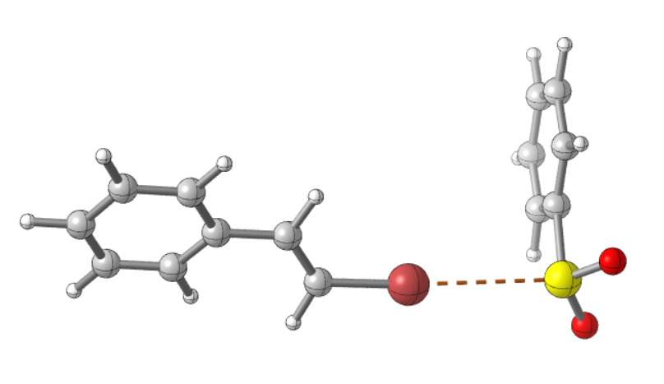
175.1
o
3.30 Å
Figure SI-7. HB complex between 1a and 2a calculated at the wB97x-D/Def2TZVPP.

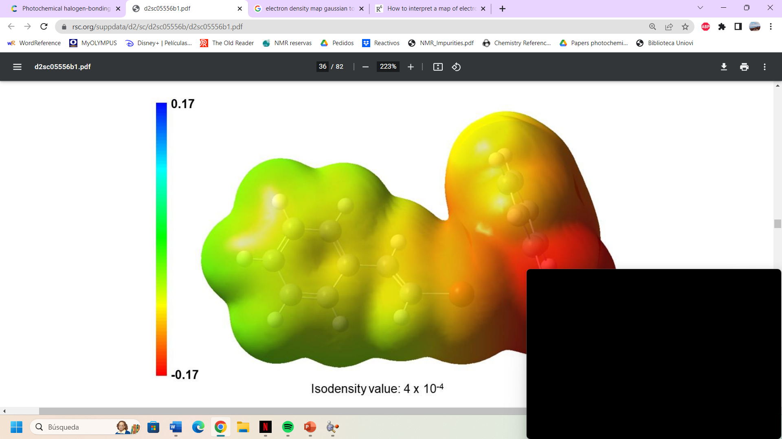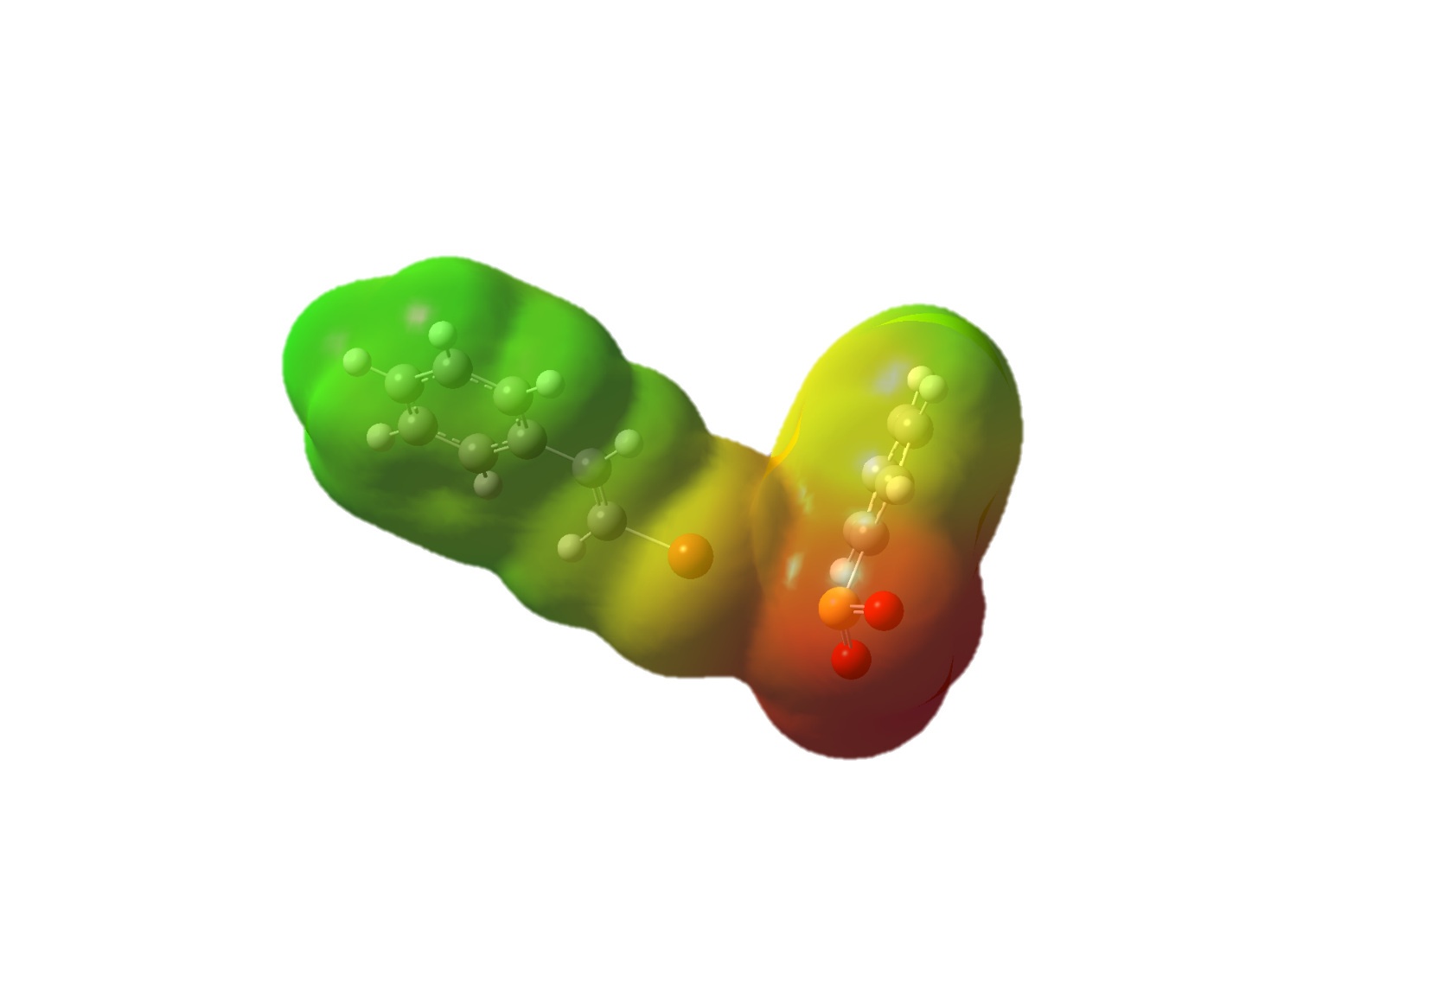
0.23
- 0.23
Isodensity value: 4 x 10⁻⁴
Figure SI-8. Calculated electrostatic potential map (red = negative electrostatic potential) on the 0.0004 au isodensity surface.

$$∆H=-2.6 kcal∙{mol}^{-1}; ∆G\left(solv\right)=+9.3 kcal∙{mol}^{-1}$$
Characterization vinyl radical species.
The structure of vinyl radicals as bent σ-type or linear π-type structures has been the object of study over the years, and is largely influenced by the substituents. For β-substituted vinyl radicals experimental and computational studies point to the existence of two interconverting sp² bent σ-type structures while the sp linear structure could be the transition structure for this inversion, instead of a real intermediate.^{[18]} Our own computational calculations are in agreement with this proposal as we have found that for styryl radical (7a) the bent σ-type structures (cis-7a) and (trans-7a) are minima in the potential energy surface, that might interconvert through the linear π-type structure (8a), which has been characterized as saddle point (Figure SI-9 and SI-10). A Gibbs free energy of activation for the interconversion of 3.8 and 3.1 kcal·mol⁻¹ were obtained respectively (figure SI-9). According to this model, the stereoconvergence observed might be explained considering an interconversion rate of the bent σ-type radicals faster than the radical recombination. Moreover, the preference towards the E isomer might justified considering that the radical recombination on cis-7a is disfavoured for steric reasons when compared to trans-7a.
Figure SI-9. Calculations in the interconversion of cis-7a and trans-7a through 8a.
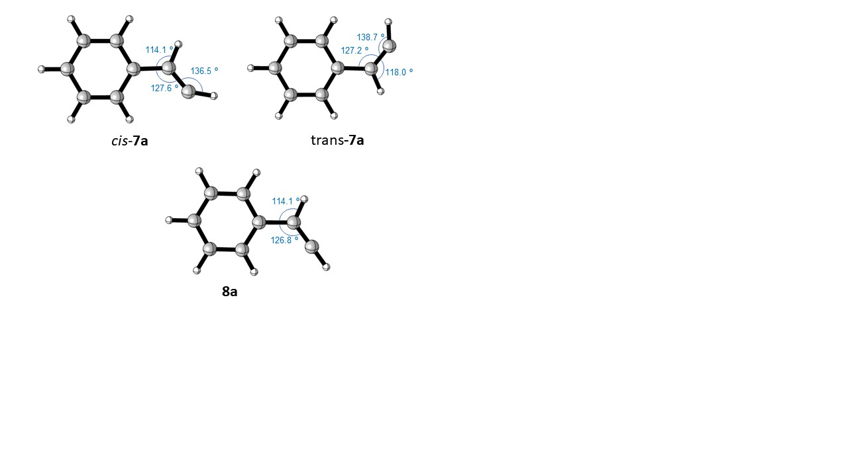
Figure SI-10. Structure and relative energies of alkenyl radical cis-7a, trans-7a and 8 computed at the M06-2X/ Def2-TZVPP level of theory.
Cartesian Coordinates and energy data
β-bromostyrene 1a

C 1.116212 0.422628 -0.083875
H 0.947304 1.465540 -0.304211
C 0.156670 -0.469797 0.108556
H 0.434454 -1.500492 0.298317
C -2.168599 -1.272043 0.002422
C -3.537899 -1.071388 -0.060133
C -4.051699 0.215036 -0.056933
C -3.185249 1.297610 0.015405
C -1.818751 1.096414 0.078922
C -1.286418 -0.194123 0.063024
H -1.772349 -2.279987 -0.001711
H -4.204599 -1.922099 -0.109210
H -5.120251 0.376006 -0.105328
H -3.579771 2.305043 0.030530
H -1.162563 1.953432 0.154356
Br 2.946062 -0.015527 -0.010488

SCF energy: -2883.26439080 Hartree
Gibbs free energy: -2883.174132 Hartree
SCF energy (CPCM-dmso): -2883.26882569 Hartree
Gibbs free energy (CPCM-dmso): -2883.17413 Hartree

Sodium benzenesulfonate 2a

C -2.158991 -1.200514 0.036826
C -0.774251 -1.197874 -0.066343
C -0.075371 -0.000108 -0.118709
C -0.773959 1.197783 -0.065672
C -2.158705 1.200685 0.037546
C -2.855954 0.000159 0.084213
H -2.697895 -2.140125 0.089508
H -0.207724 -2.121777 -0.076894
H -0.207149 2.121517 -0.075741
H -2.697386 2.140391 0.090798
H -3.936553 0.000263 0.168620
S 1.765932 -0.000303 -0.347875
O 2.142205 1.249690 0.369228
O 2.142192 -1.249216 0.371091

SCF energy: -780.348815932 Hartree
Gibbs free energy: -780.283897 Hartree
SCF energy (CPCM-dmso): -780.44265047 Hartree
Gibbs free energy (CPCM-dmso): -780.377346 Hartree

HB complex

C 3.731955 2.616649 0.971938
C 3.538002 1.252139 1.136845
C 3.517796 0.409873 0.034414
C 3.692589 0.940800 -1.235504
C 3.886623 2.304752 -1.404282
C 3.903016 3.147341 -0.300041
H 3.755754 3.270260 1.836719
H 3.423561 0.812504 2.120401
H 3.697995 0.261174 -2.079301
H 4.031621 2.714729 -2.397394
H 4.054985 4.212172 -0.430819
S 3.161295 -1.389187 0.248838
O 3.918006 -1.983702 -0.881646
O 3.740961 -1.653137 1.589681
C -1.937390 -0.772327 -0.430506
H -2.325815 -1.249577 -1.320467
C -2.699869 -0.044035 0.376270
H -2.255369 0.377683 1.271247
C -4.897879 0.648707 1.265731
C -6.255699 0.891801 1.135573
C -6.880671 0.717235 -0.088973
C -6.130003 0.305701 -1.181981
C -4.773761 0.065728 -1.050898
C -4.132360 0.219849 0.180384
H -4.416918 0.785166 2.226504
H -6.826363 1.219471 1.995193
H -7.940532 0.907540 -0.195905
H -6.603899 0.179852 -2.147093
H -4.201476 -0.229293 -1.920496
Br -0.103432 -1.090436 -0.144517

SCF energy: -3663.61968151 Hartree
Gibbs free energy: -3663.447016 Hartree
SCF energy (CPCM-dmso): -3663.71379984 Hartree
Gibbs free energy (CPCM-dmso): -3663.541134Hartree

Radical cis-7a
C 1.705900 -1.047699 0.000000
C 0.336200 -1.272299 0.000000
C -0.560000 -0.206500 0.000000
C -0.055700 1.095700 0.000000
C 1.308999 1.320400 0.000000
C 2.196300 0.248900 0.000000
H 2.388600 -1.886799 0.000000
H -0.045600 -2.286000 0.000000
H -0.748000 1.928700 -0.000100
H 1.686600 2.334200 0.000000
H 3.263099 0.427200 0.000000
C -2.009100 -0.472200 -0.000100
H -2.295199 -1.525999 0.000000
C -2.958399 0.430000 0.000100
H -4.035099 0.429799 0.000200
H -2.550500 1.451576 0.000189

SCF energy: -308.93624829 Hartree
Gibbs free energy: -308.847251 Hartree
SCF energy (IEFPCM-dmso): -308.94013428 Hartree
Gibbs free energy (IEFPCM-dmso): -308.85113728 Hartree

Radical trans-7a
C -1.709000 -1.031800 0.000100
C -0.343100 -1.277200 0.000000
C 0.571400 -0.226300 0.000000
C 0.086000 1.082299 0.000000
C -1.275599 1.328499 0.000000
C -2.179800 0.272099 0.000100
H -2.404099 -1.860700 0.000100
H 0.023100 -2.296500 0.000000
H 0.781699 1.911300 -0.000100
H -1.636600 2.348400 0.000000
H -3.243599 0.467000 0.000100
C 2.018499 -0.532299 -0.000100
H 2.261400 -1.593900 0.000100
C 3.008899 0.323500 -0.000100
H 3.155799 1.390700 0.000100
H 3.975564 -0.201437 -0.000389

SCF energy: -308.9346037 Hartree
Gibbs free energy: -308.846063 Hartree
SCF energy (IEFPCM-dmso): -308.93871906 Hartree
Gibbs free energy (IEFPCM-dmso): -308.85017806 Hartree

Radical-8
C 1.718800 -1.028400 0.000000
C 0.352800 -1.274499 0.000000
C -0.558900 -0.223100 0.000000
C -0.076900 1.085700 0.000000
C 1.284199 1.332599 0.000000
C 2.188299 0.275800 0.000000
H 2.414800 -1.856599 0.000000
H -0.014200 -2.293800 0.000000
H -0.782400 1.907399 0.000000
H 1.645799 2.352299 0.000000
H 3.252099 0.471000 0.000000
C -2.010700 -0.520299 0.000000
H -2.247499 -1.588900 0.000000
C -2.981800 0.342800 0.000100
H -3.763300 1.065100 0.000100
H -3.720514 -0.472235 0.004446

ν = -716.7 cm⁻¹
SCF energy: -308,9280196 Hartree
Gibbs free energy: -308,841058 Hartree
SCF energy (IEFPCM-dmso): - 308,93207840Hartree
Gibbs free energy (IEFPCM-dmso): -308,84511640 Hartree

6. NMR titration experiments.
For these experiments, a range of solutions was made, with incremental amounts of vinyl bromide 1a while maintaining a constant quantity of sulfinate salt 2a. All samples were prepared in d⁶-DMSO to enable straightforward NMR analysis. By means of the titration, a continuous downfield shift of the signals of sulfinate salt 2a was observed, as well as a small upfield shift on the signals of vinyl bromide 1a.
2a + 1a
5:1

2a + 1a
2:1

2a + 1a
1:1

Sodium salt 2a
Vinyl bromide 1a
Figure SI-11. Titration ¹H-NMR spectra.
The composition of each sample and its corresponding ¹H-NMR spectra are presented below:
- Sample 1
Preparation: 2a (49.2 mg, 0.2 mmol) was dissolved in 0.4 mL of d⁶-DMSO in a 5 mL vial.
Sodium salt 2a
Figure SI-12. ¹H-NMR spectra recorded for the Sample 1 in d⁶-DMSO.
Chemical shift of 2a: 7.51 ppm.

- Sample 2
Preparation: 1a (26 µL, 0.2 mmol) was dissolved in 0.4 mL of d⁶-DMSO in a 5 mL vial.
Vinyl bromide 1a
Figure SI-13. ¹H-NMR spectra recorded for the Sample 2 in d⁶-DMSO.
Chemical shift of 1a: 6.71 ppm.

- Sample 3
Preparation: 1a (26 µL, 0.2 mmol) and 2a (42.9 mg, 0.2 mmol) were dissolved in 0.4 mL of d⁶-DMSO in a 5 mL vial.
2a + 1a
1:1

Figure SI-14. ¹H-NMR spectra recorded for the Sample 3 in d⁶-DMSO.
Chemical shift of 2a: 7.54 ppm.
Chemical shift of 1a: 6.71 ppm.

- Sample 4
Preparation: 1a (51.6 µL, 0.4 mmol) and 2a (49.2 mg, 0.2 mmol) were dissolved in 0.4 mL of d⁶-DMSO in a 5 mL vial.
2a + 1a
2:1

Figure SI-15. ¹H-NMR spectra recorded for the Sample 3 in d⁶-DMSO.
Chemical shift of 2a: 7.57 ppm.
Chemical shift of 1a: 6.70 ppm.

- Sample 5
Preparation: 1a (129 µL, 1 mmol) and 2a (49.2 mg, 0.2 mmol) were dissolved in 0.4 mL of d⁶-DMSO in a 5 mL vial.
2a + 1a
5:1

Figure SI-16. ³¹H-NMR spectra recorded for the Sample 4 in d⁶-DMSO.
Chemical shift of 2a: 7.61 ppm.
Chemical shift for 1a: 6.68 ppm.

Based on these measurements, we calculated the thermodynamic binding constant associated to the formation of the halogen-bonding complex between 1a and 2a. For this purpose, we utilized the Bindfit application, which is available online free of charge and open-access.^{[19]} Following the instructions in the website, we first prepared an excel document with the necessary data to perform the calculations: Concentrations of the host (sulfinate salt 2a) /gest (alkenyl bromide 1a) solutions and the observed NMR chemical shifts measured in the titration experiments (Figure SI-17).
Entry | Host concentration / M | Guest concentration / M | Proton 1 (2a)
1 | 0,5 | 0 | 7,511
2 | 0,5 | 0,5 | 7,544
3 | 0,5 | 1 | 7,565
4 | 0,5 | 2,5 | 7,607
Figure SI-17. Host/guest concentration of the different NMR samples and observed chemical shift for the signal of 2a.
With all the raw data, the instructions in the previously described website were followed step by step in order to calculate the desired binding constant (K).
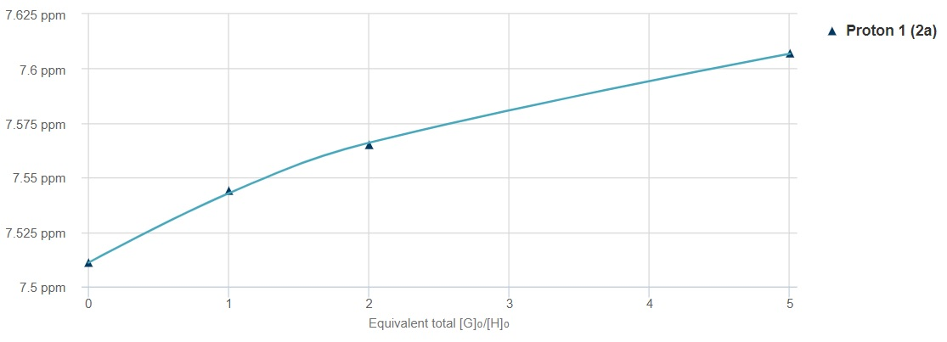
Figure SI-18. Representation of the ¹H-NMR chemical shift (y axis) versus [G]₀/[H]₀

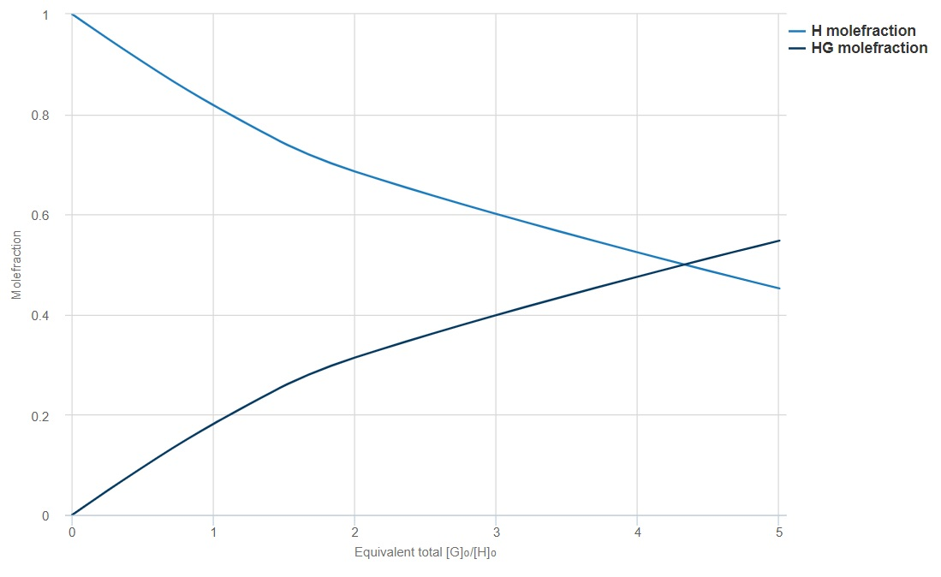
Figure SI-19. Molefraction representation
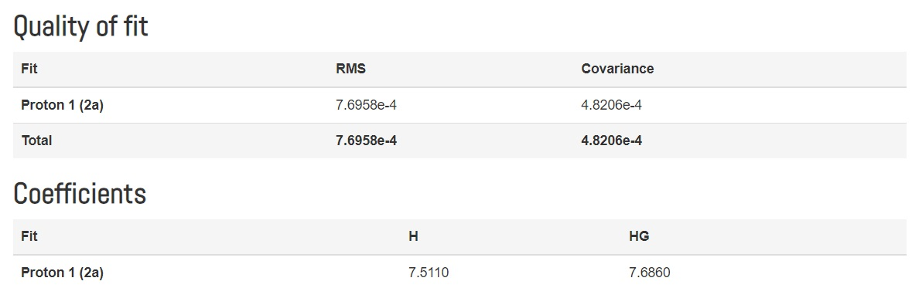
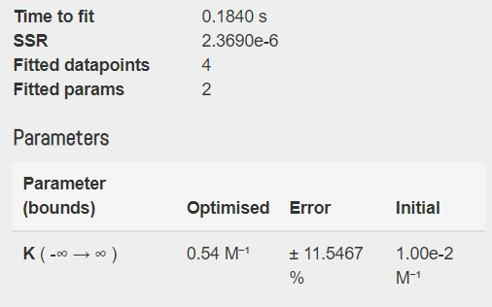
Figure SI-20. Output data from Bindfit. Calculation of the binding constant K.

7. Quantum yield determination
The quantum yield measurement was performed following a procedure described by Dell’ Amico and coworkers.^{[20]} This method involves a ferrioxalate actinometry solution where the decomposition of ferric ions to ferrous ions, by irradiation at a particular wavelength, is measured.^{[21]} To achieve this, the ferrous ions are complexed with 1,10-phenanthroline and its absorbance at 510 nm by UV/Vis is determined.^{[22]} Finally, the moles of iron-phenanthroline complex formed are associated to the moles of photons absorbed.
Actinometry measurements:
Preparation of the solutions:
- Potassium ferrioxalate solution: 294.7 mg of potassium ferrioxalate, 139 µl of sulfuric acid (96 %) were added to a 50 ml volumetric flask and filled with distilled water.
- Phenanthroline solution: 0.2 % by weight of 1,10-phenanthroline in water was prepared in a 50 ml volumetric flask.
- Buffer solution: 2.47 g of NaOAc and 0.5 ml of sulfuric acid (96 %) were added to a 50 ml volumetric flask and filled with distilled water.
- Reaction solution: Following the general procedure A, vinyl bromide 1a (52 µL, 0.4 mmol) and sulfinate salt 2a (98.4, 0.6 mmol) were dissolved in 4 mL of dry DMSO.
These solutions were stored in the dark.
Procedure:
Although our reaction was performed irradiating at 440 nm, the quantum yield calculations have been completed by irradiating with a 456 nm LED Kessil lamp at 25% intensity. This way, monitoring the reaction is easier as it proceeds slower.
- A 5 mL glass vial was charged with 1 ml of the potassium ferrioxalate solution and placed 9 cm away from the 456 nm LED lamp. To monitor the decomposition reaction, this step was performed four different times varying only the irradiation time for each sample: 0, 2, 4 and 20 seconds. All were irradiated at 25% intensity of the 456 nm LED Kessil lamp.
- Once the sample was irradiated, it was transferred from the vial to a 10 ml volumetric flask. To this flask, 0.5 ml of the phenanthroline solution and 2 ml of the buffer solution were added and the flask was filled with distilled water.
- The reaction was stirred in the dark for 1 hour to achieve complete complexation between the phenanthroline and Fe²⁺.
- For each time interval sample a UV/Vis spectra was recorded. An overlap of these spectra is shown in the Figure SI-21.

Figure SI-21. Actinometry UV/Vis spectra of samples irradiated at 456 nm LED during different time periods.

- After measurement of all samples, the moles of Fe²⁺ formed (N) can be determined by using Beer’s Law.
$${mmolFe}^{2+}=\frac{V_{1}V_{3}{ΔA}_{(510nm)}}{{{10}^{3}V_{2}lε}_{(510nm)}}$$
Equation SI-1. Lambert-Beer’s law.
In this equation: V₁ is the irradiated volume (1 ml), V₂ is the aliquot of the irradiated potassium ferrioxalate solution (1 ml), V₃ is the final volume after complexation (10 ml), ΔA_{(510 nm)} is the difference in absorbance between the irradiated solution and the one at 0 seconds, l is the optical path-length of the irradiation cell (1 cm), and ε_{(510 nm)} is the molar extinction coefficient of the complex (11100 L mol⁻¹ cm⁻¹).
- The photon flux (F) was obtained by plotting the moles of Fe²⁺ formed (N) versus the time (t) (Figure SI-22).

Figure SI-22. Actinometry UV/Vis spectra of samples irradiated at 456 nm LED during different time periods.

Knowing that the slope follows the equation F=N/ ϕFe²⁺ t; and that ϕFe²⁺ = 0.9 at λ = 456 nm:
F = 5.20 10⁻⁸ einstein s⁻¹
- Finally, a correction factor (C) must be considered. The absorbance of the ferrioxalate solution at 510 nm using the 456 nm LED lamp is 0.23. Only if this value is higher than 2 it can be said that all the incident light is absorbed, as in our case this value is lower, a correction factor is needed to recalculate the photon flux (F_{corrected}).
$${ϕFe}^{2+}=\frac{\left(\frac{δ_{moles{Fe}^{2+}}}{δ_{time}}\right)}{{FC}_{{Fe}^{3+}}} C_{{Fe}^{3+}}=\left[1-{10}^{-A(λ)}\right]$$
Equation SI-2. Relationship between the correction factor (C) and the quantum yield equation.

As A_{456nm} = 0.23; C = 0.415 and F_{corrected} = 1.25 10⁻⁷ einstein s⁻¹.

- The reaction solution previously described was irradiated in the same way as in the actinometry experiment. The moles of product formed (compound 3aa) were determined by taking aliquots of the reaction of 300 µL and following conversion via ¹H-NMR at different intervals of time (0, 10, 20 and 30 min). Once this was done, the moles of product formed were related to the number of photons per unit of time (Figure SI-23).

Figure SI-23. Representation of the moles of product 3aa formed related to the number of total incident photons.

Given that the absorbance of the irradiation mixture at that wavelength is higher than 2 (A₄₅₆>2), no correction factor needs to be applied in this case since it can be assumed that all the incident light is absorbed. The registered slope is the value of the quantum yield of our reaction. $ϕ$ = 0.91.

8. References
[1] a) For the synthesis of the vinyl bromides 1, we followed a two-step sequence based on a dibromoolefination reaction of the corresponding aldehyde precursor (A. R. Silva, E. C. Polo, N. C. Martins, Correia, D. C. Roque. Adv. Synth. Catal. 2018, 360, 346.) followed by a dehalogenation reaction (Y. Ye, H. Chen, K. Yao, H. Gong, Org. Lett. 2020, 22, 2070.). b) The Z-configured vinyl bromide 1a’ was synthesized following this procedure: K. G. Tang, G. T. Kent, I. Erden, W. Wu, Tetrahedron Lett. 2017, 58, 3894.
[2] G. Bogonda, D. V. Patil, H. Y. Kim, K. Oh, Org.Lett. 2019, 21, 3774−3779
[3] G. W. Rong, J. C. Mao, J. Org. Chem. 2015, 80, 7652-7657.
[4] S. An, K. H. Song, S. Lee, Org. Biomol. Chem., 2021, 19, 7827-7831.
[5] L. Zhu, D. Song, Y. Liu, M. Chen, X. Zhang, M. You, J. Zhan, Org. Biomol. Chem., 2022, 20, 9127-9131.
[6] P. Katrun, S. Hlekhlai, J. Meesin, M. Pohmakotr, V. Reutrakul, T. Jaipetch, D. Soorukrama and C. Kuhakarn Org. Biomol. Chem., 2015, 13, 4785–4794
[7] S. Reddy, S. Thadkapally, M. Mamidyala, J. B. Nanubolub, R. S. Menon, RSC Adv., 2015,5, 8199-8204
[8] S. Paul, J. Guin, Green Chem., 2017,19, 2530-2534
[9] L. Wang, H. Yue, D. Yang, H. Cui, M. Zhu, J. Wang, W. Wei, H. Wang, J. Org. Chem. 2017, 82, 6857–6864.
[10] F. Li, G. Zhang, Y. Liu, B. Zhu, Y. Leng, J. Wu, Org. Lett., 2020, 22, 8791–8795
[11] Y. Jianga, T. Loh, Chem. Sci., 2014,5, 4939-4943.
[12] X. Wu, W. Zhang, G. Sun, X. Zou, X. Sang, Y. He, B. Gao, Nat. Commun. 2023, 14, 5168-5178.
[13] V. Padmavathi, K. Venugopal Reddy, A. Balaiah, T. V. Ramana Reddy, D. Bhaskar Reddy, Heteroat. Chem., 2002, 13, 677-682
[14] Gaussian 09, Revision B.01, M. J. Frisch, G. W. Trucks, H. B. Schlegel, G. E. Scuseria, M. A. Robb, J. R. Cheeseman, G. Scalmani, V.Barone, B. Mennucci, G. A. Petersson, H. Nakatsuji, M. Caricato, X. Li, H. P. Hratchian, A. F. Izmaylov, J. Bloino, G. Zheng, J. L. Sonnenberg, M. Hada, M. Ehara, K. Toyota, R. Fukuda, J. Hasegawa, M. Ishida, T. Nakajima, Y. Honda, O. Kitao, H. Nakai, T. Vreven, J. A. Montgomery, Jr., J. E. Peralta, F. Ogliaro, M. Bearpark, J. J. Heyd, E. Brothers, K. N. Kudin, V. N. Staroverov, T. Keith, R. Kobayashi, J. Normand, K. Raghavachari, A. Rendell, J. C. Burant, S. S. Iyengar, J. Tomasi, M. Cossi, N. Rega, J. M. Millam, M. Klene, J. E. Knox, J. B. Cross, V. Bakken, C. Adamo, J. Jaramillo, R. Gomperts, R. E. Stratmann, O. Yazyev, A. J. Austin, R. Cammi, C. Pomelli, J. W. Ochterski, R. L. Martin, K. Morokuma, V. G. Zakrzewski, G. A. Voth, P. Salvador, J. J. Dannenberg, S. Dapprich, A. D. Daniels, O. Farkas, J. B. Foresman, J. V. Ortiz, J. Cioslowski, and D. J. Fox, Gaussian, Inc., Wallingford CT, 2010.
[15] Y.-S. Lin, G.-D. Li, S. P. Mao, J.-D. Chai Long-Range Corrected Hybrid Density Functionals with Improved Dispersion Corrections J. Chem. Theory Comput. 2013, 9, 1, 263.
[16] (a) Zhao Y.; Truhlar, D. Theor. Chem. Account 2008, 120, 215-241. (b) Xu, X.; Alecu I. M.; Truhlar, D. G. J. Chem. Theory Comput. 2011, 7, 1667–1676.
[17] CYLview20; Legault, C. Y., Université de Sherbrooke, 2020 (http://www.cylview.org).
[18] a) C. Galli, A. Guarnieri, H. Koch, P. Mencarelli, Z. Rappoport, J. Org. Chem. 1997, 62, 4072–4077. b) C. Galli, Z. Rappoport, Acc. Chem. Res. 2003, 36, 580–587. c) T. P. M. Goumans, K. van Alem, G. Lodder, European J. Org. Chem. 2008, 2008, 435–443.
[19] The website tool Bindfit is open access and available to a general public through the following link: https://urldefense.com/v3/__http://supramolecular.org/__;!!D9dNQwwGXtA!W8BJfdU5UufikVjU0daGfmcAH1DBbku2p2znhU7Ag_rmjTKY1eemU2vSQA660Iux8uGICmHS6PROv8I7orosp7e7Mjnag7qe$
[20] S. Cuadros, C. Rosso, G. Barison, P. Costa, M. Kurbasic, M. Bonchio, M. Prato, G. Filippini and L. Dell’Amico, Org. Lett., 2022, 24, 2961.
[21] S. L. Murov, Handbook of Photochemistry, Marcel Dekker, New York, 1973.
[22] H. J. Kuhn, S. E. Braslavsky, R. Schmidt, Chemical Actinometry (IUPAC Technical Report), Pure Appl. Chem., 2004, 76, 2105.
9. Copies of the NMR spectra
(E)-O,O-dimethyl S-styryl phosphorothioate (3aa)

(E)-2-(2-(phenylsulfonyl)vinyl)naphthalene (3ba)

(E)- 1,3-dimethyl-5-(2-(phenylsulfonyl)vinyl)benzene (3ca)

(E)-4-(2-(phenylsulfonyl)vinyl)benzonitrile (3da)

(E)-1-nitro-4-(2-(phenylsulfonyl)vinyl)benzene (3ea)

(E)-1-fluoro-4-(2-(phenylsulfonyl)vinyl)benzene (3fa)

(E)-1-methoxy-4-(2-(phenylsulfonyl)vinyl)benzene (3ga)

(E)-methyl(4-(2-(phenylsulfonyl)vinyl)phenyl)sulfane (3ha)

(E)-1-chloro-3-(2-(phenylsulfonyl)vinyl)benzene (3ia)

(E)- 1-bromo-3-(2-(phenylsulfonyl)vinyl)benzene (3ja)

(E)-1-iodo-3-(2-(phenylsulfonyl)vinyl)benzene (3ka)

(E)-3-(2-(phenylsulfonyl)vinyl)benzoate (3la)

(E)-2-(2-(phenylsulfonyl)vinyl)thiophene (3ma)

(E)-2-(2-(phenylsulfonyl)vinyl)benzofuran (3na)

(E)-2-methoxy-4-(2-(phenylsulfonyl)vinyl)phenol (3oa)

(S,E)-1-((3,7-dimethyloct-6-en-1-yl)oxy)-2-methoxy-4-(2-(phenylsulfonyl)vinyl) benzene (3pa)

(3aR,5R,6S,6aR)-5-((R)-2,2-dimethyl-1,3-dioxolan-4-yl)-2,2-dimethyltetrahydrofuro [2,3-d][1,3]dioxol-6-yl 4-((E)-2-(phenylsulfonyl)vinyl)benzoate (3qa)

(E)-1-fluoro-4-(styrylsulfonyl)benzene (3ab)

(E)- 1-chloro-4-(styrylsulfonyl)benzene (3ac)

(E)-1-methoxy-4-(styrylsulfonyl)benzene (3ad)

(E)-1-methyl-4-(styrylsulfonyl)benzene (3ae)

(E)-1-(styrylsulfonyl)-2-(trifluoromethyl)benzene (3af)

(E)-2-(styrylsulfonyl)thiophene (3ag)

(E)-3-(styrylsulfonyl)pyridine (3ah)

(E)-(2-(cyclopropylsulfonyl)vinyl)benzene (3ai)

(E)-(2-(methylsulfonyl)vinyl)benzene (3aj)

(E)-1-fluoro-4-(2-(methylsulfonyl)vinyl)benzene (3fj)

(E)-(2-(cyclohexylsulfonyl)vinyl)benzene (3ak)

(E)-1-(2-(cyclohexylsulfonyl)vinyl)-4-fluorobenzene (3fk)

((1E,1'E)-sulfonylbis(ethene-2,1-diyl))dibenzene (3al)

1-methoxy-4-((E)-2-(((E)-styryl)sulfonyl)vinyl)benzene (3gl)

(((1E,3E)-4-phenylbuta-1,3-dien-1-yl)sulfonyl)benzene (5aa)

1-methoxy-4-((1E,3E)-4-(phenylsulfonyl)buta-1,3-dien-1-yl)benzene (5ba)

1-chloro-4-((1E,3E)-4-(phenylsulfonyl)buta-1,3-dien-1-yl)benzene (5ca)

1-chloro-4-(((1E,3E)-4-(4-methoxyphenyl)buta-1,3-dien-1-yl)sulfonyl)benzene (5bc)

1-((1E,3E)-4-(cyclopropylsulfonyl)buta-1,3-dien-1-yl)-4-methoxybenzene (5bi)

1-chloro-4-((1E,3E)-4-(cyclopropylsulfonyl)buta-1,3-dien-1-yl)benzene (5ci)

1-methoxy-4-((1E,3E)-4-(((E)-styryl)sulfonyl)buta-1,3-dien-1-yl)benzene (5bo)

